PHP

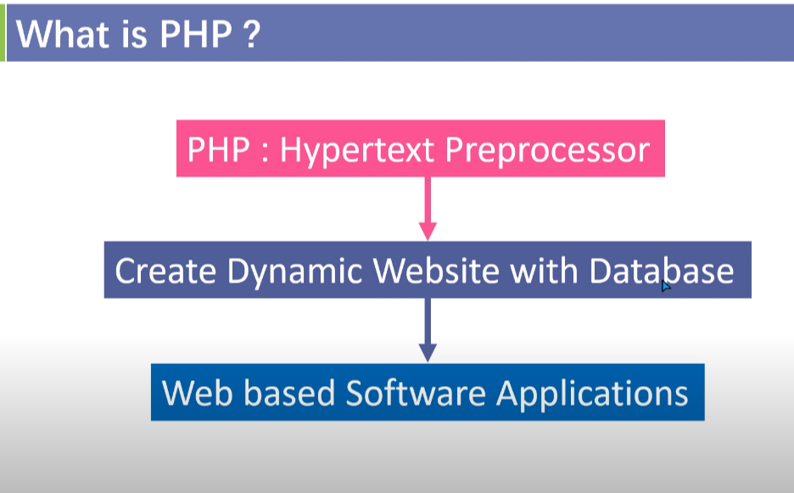

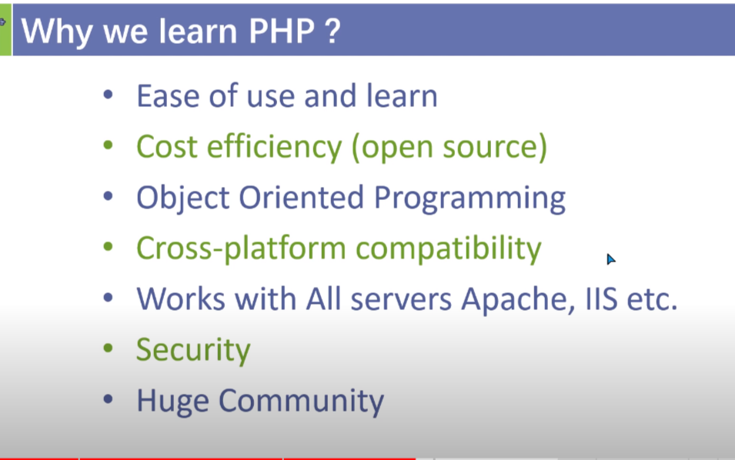

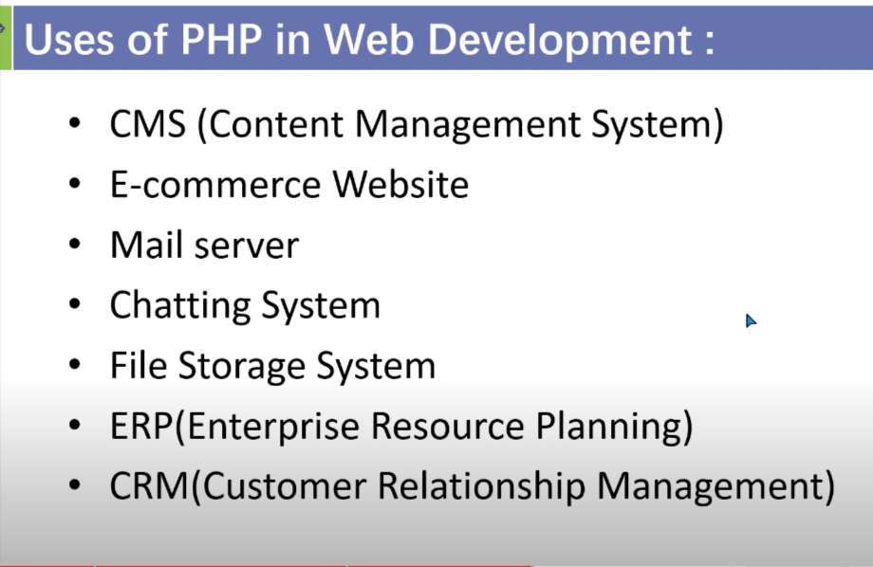

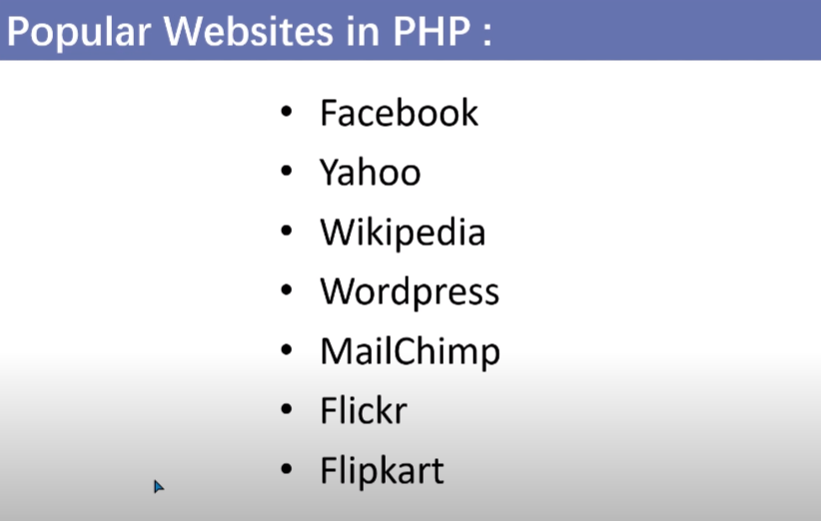

🡺 how to run a code of php:

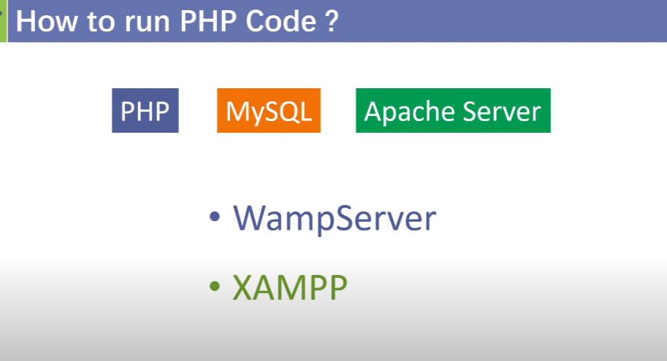

Why do we genrally use MYSQL with the php?

Ans: because MYSQL is very compatiable with the php.

PHP code structure :

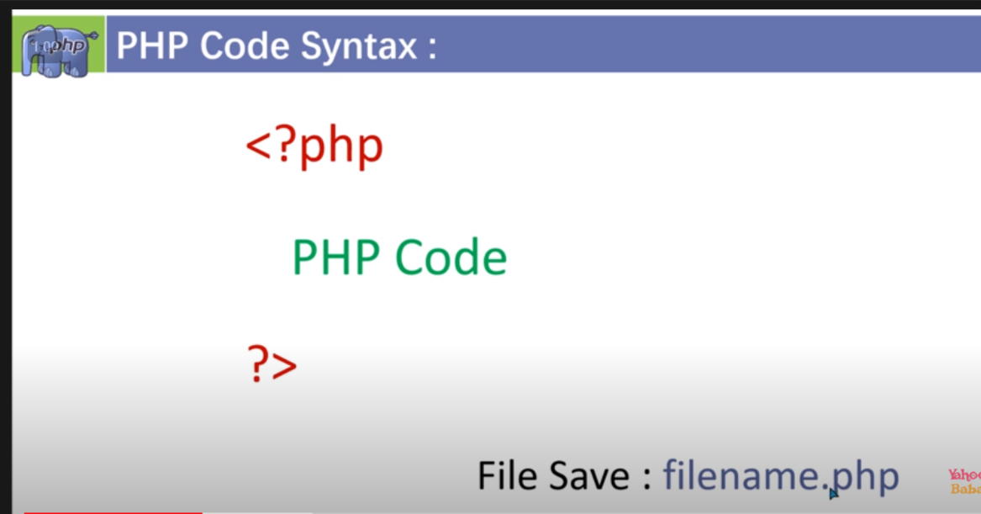

Code:

<?php

echo "hello php";

?>

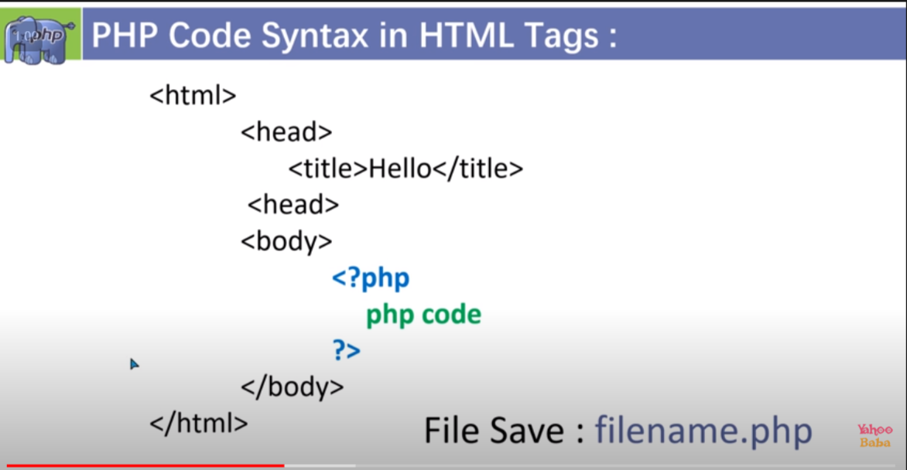

<!DOCTYPE html>

<html lang="en">

<head>

    <meta charset="UTF-8">

    <meta http-equiv="X-UA-Compatible" content="IE=edge">

    <meta name="viewport" content="width=device-width, initial-scale=1.0">

    <title>Document</title>

</head>

<body>

    <?php

    echo "Hello Php";

    ?>

</body>

</html>

PHP echo and print statement :

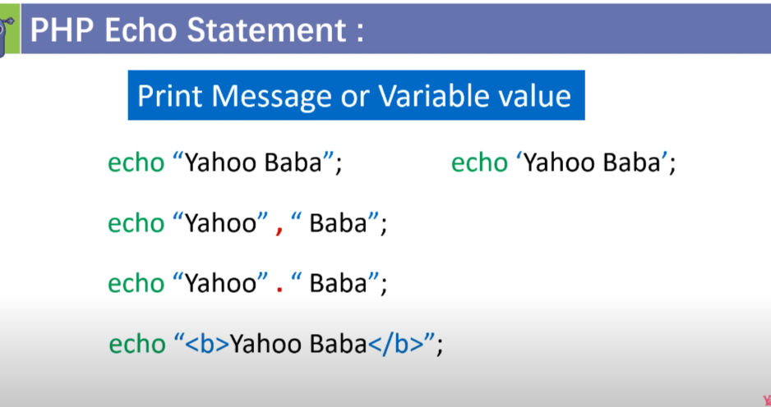

ii) print statement :

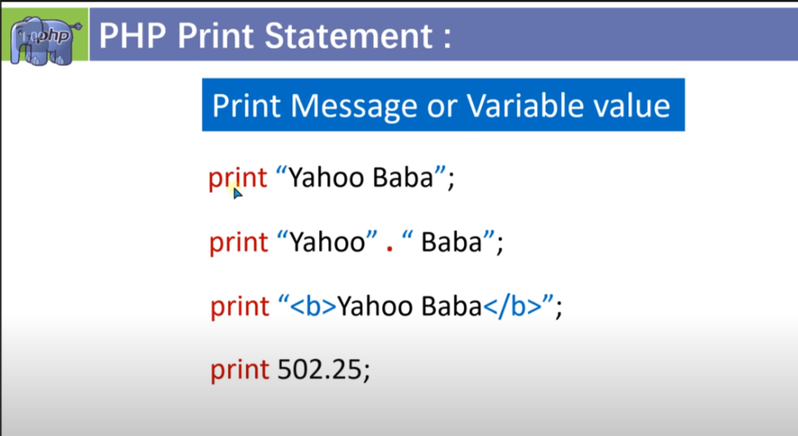

Diffrence between echo and print statement :

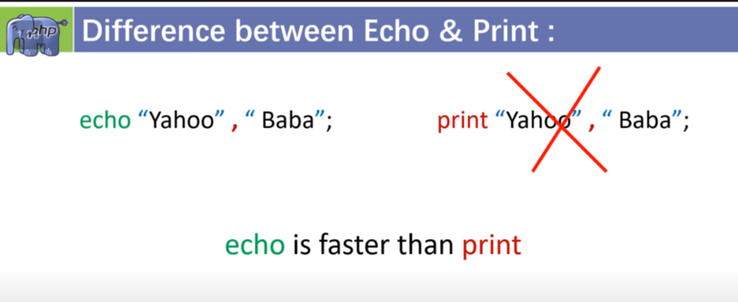

Note : to go into new line we use <br> inside echo or print

PHP variables

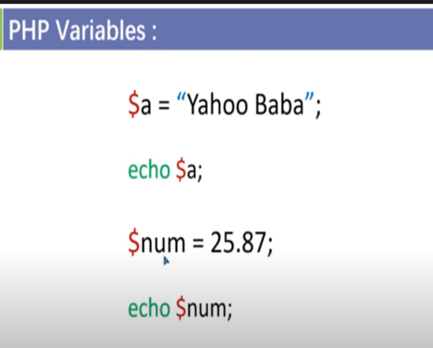 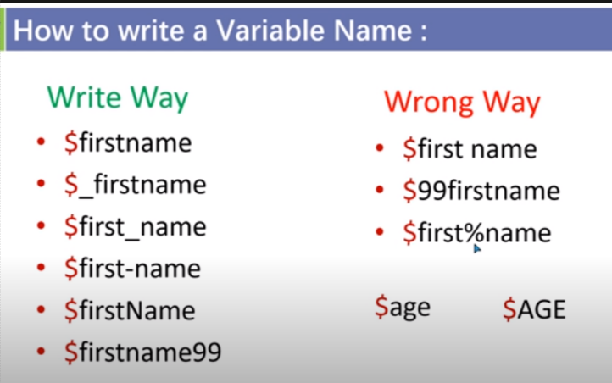

PHP data types :

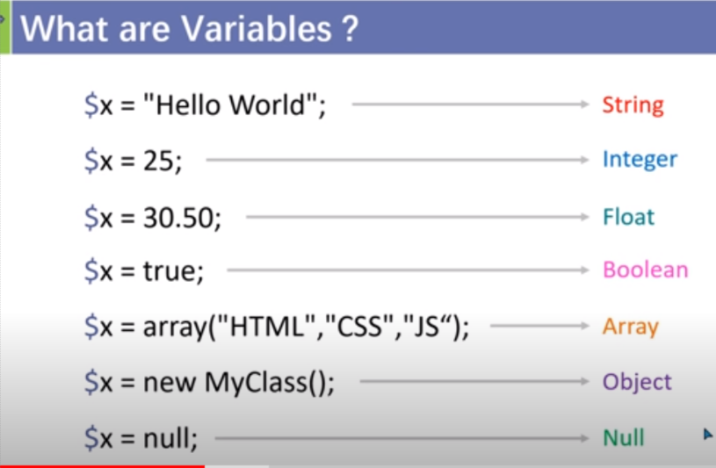

Note : To know the data types , value and length a method is : var_dump();

PHP comment:

1. Single line comment :
   1. #
   2. //
2. Multiline comment : /* php code */

Php const variable :

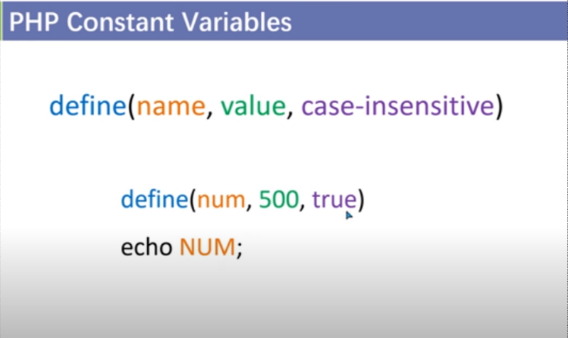 by default case-insensitive value is false ;

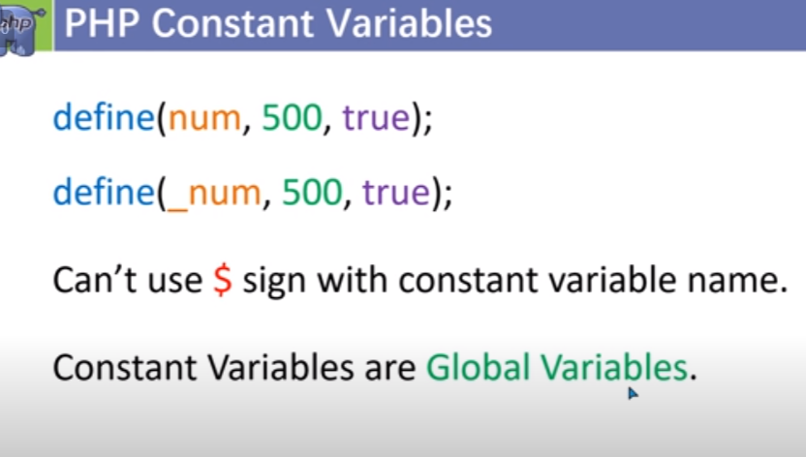

<?php

    define("test",50);

    echo test;

?>

1.Arthematic operator :

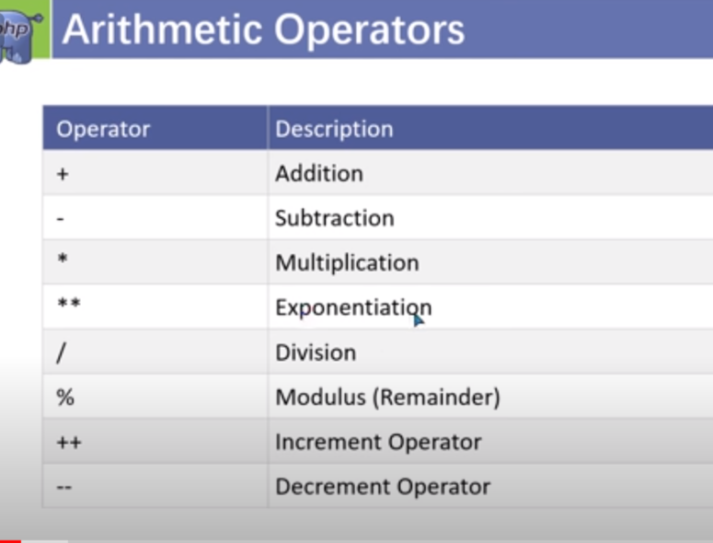

2.Assigment operator :

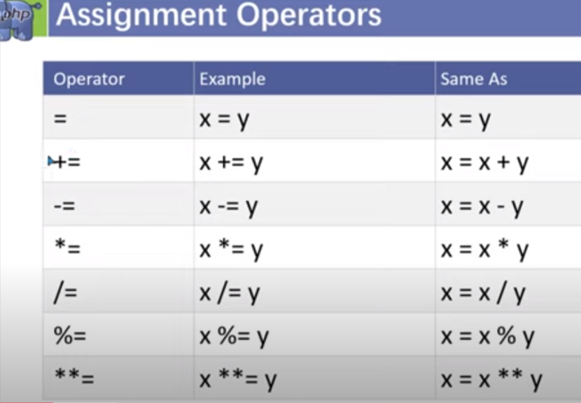

3.Comporosion operator :

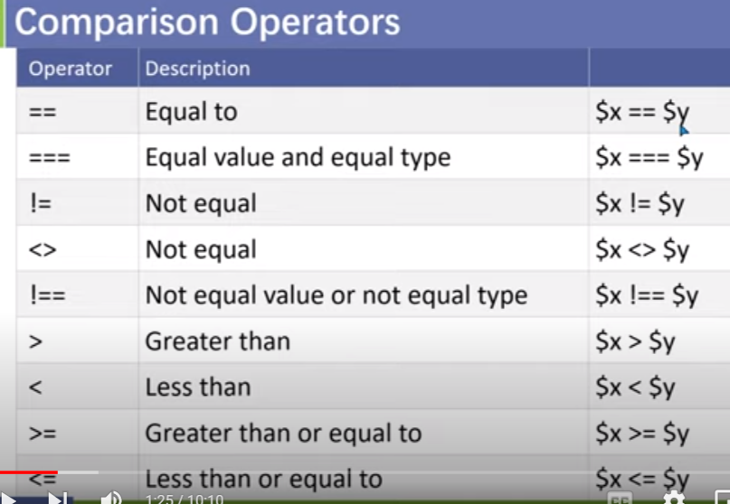

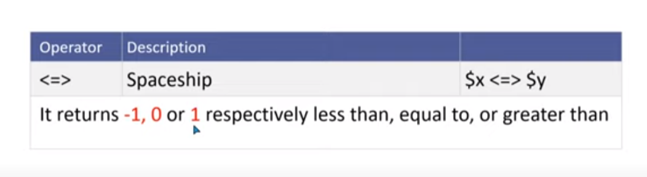

4.logical operator :

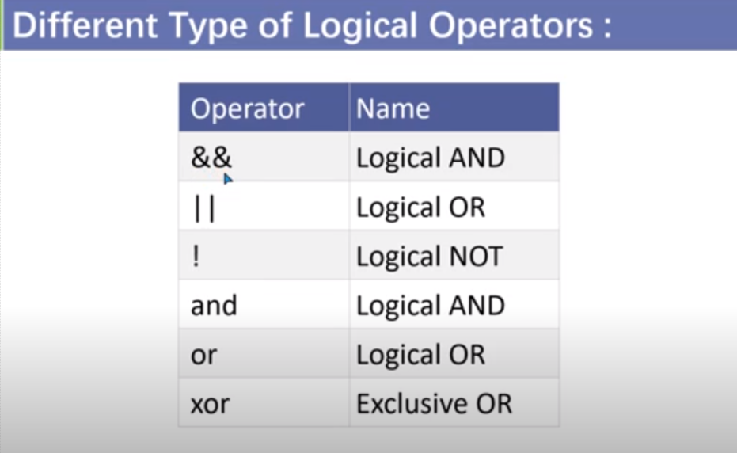

XOR operator :

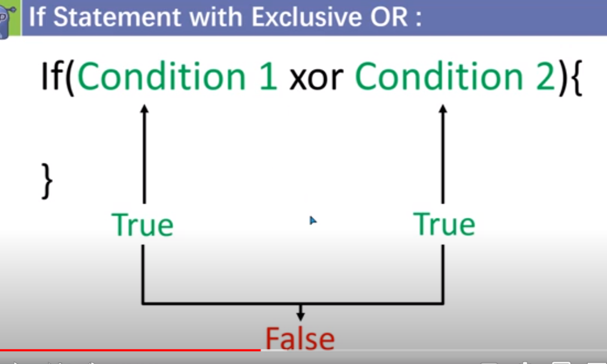

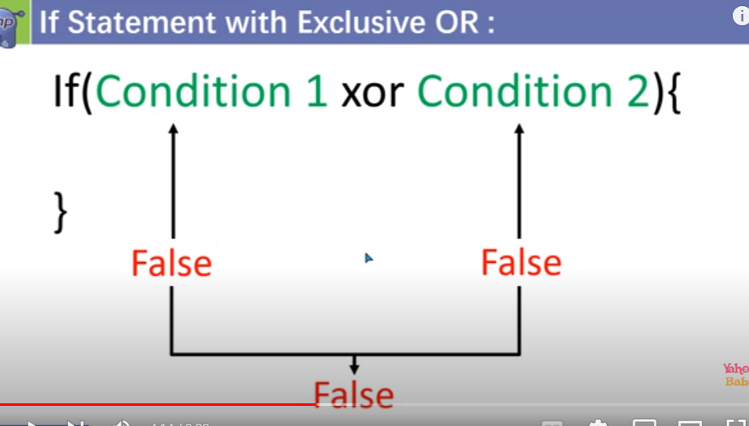

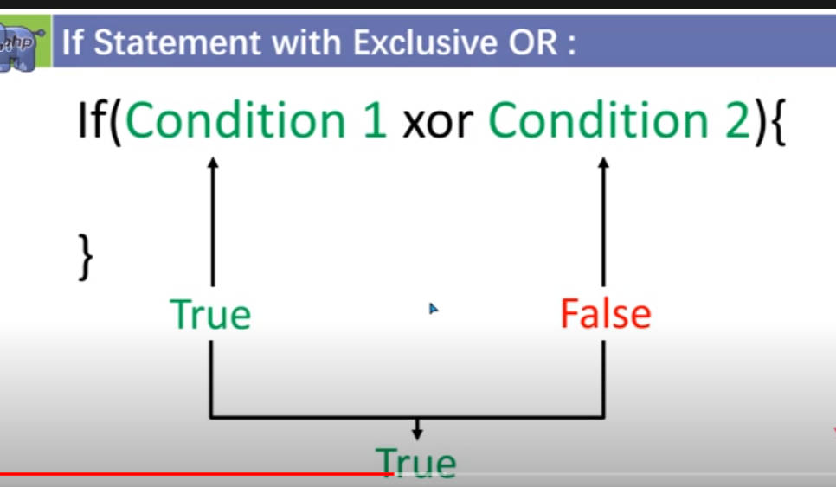

Switch statement :

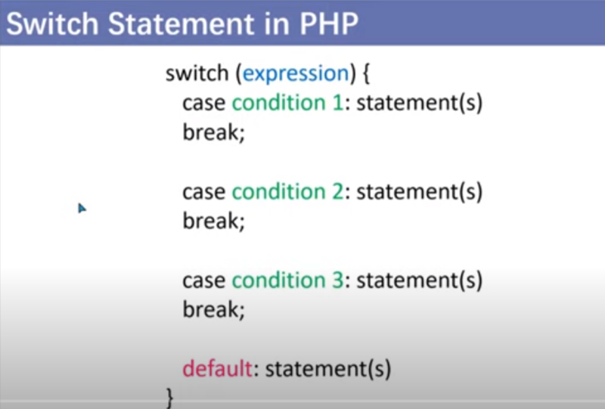

Conditional ternary operator :

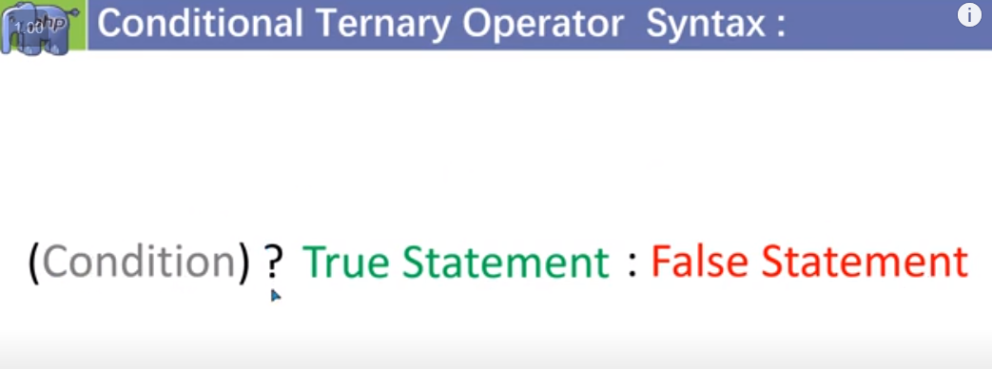

String concatenation :

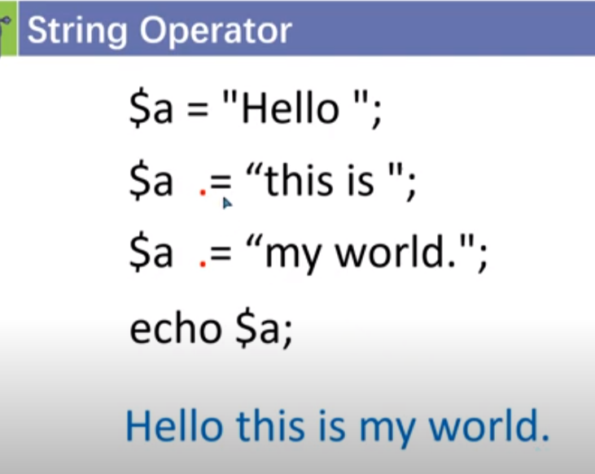

Php :

i)while loop

ii)do while loop

iii)for loop

iv)continue

v)break

vi)goto

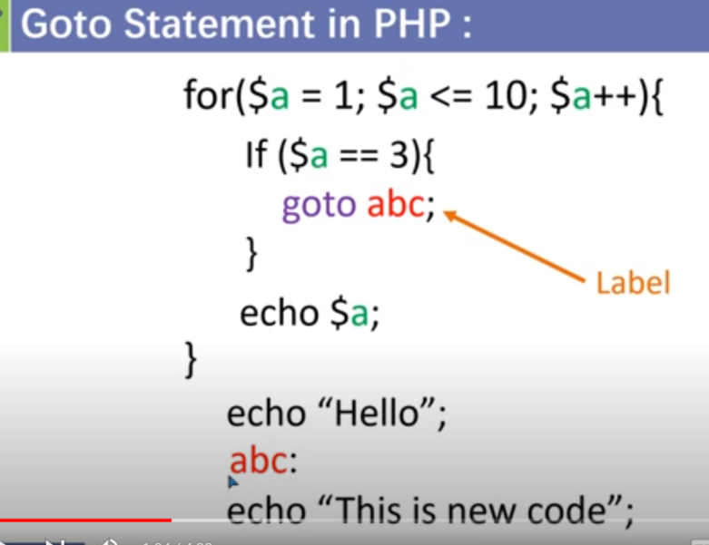

<?php

    echo ("hello i am Ajaj<br>");

    echo ("hello i am Ajaj<br>");

    goto abc;

    echo ("hello i am Ajaj<br>");

    echo ("hello i am Ajaj<br>");

    abc : echo("Goto has been called<br>");

?>

Function in PHP :

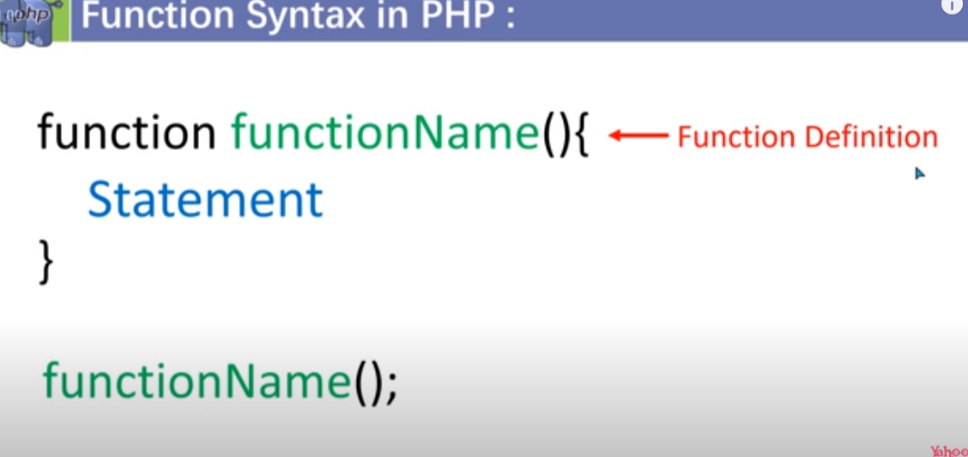

Function with the parameter :

<?php

*function* sum($a,$b){

        return $a+$b;

    }

    echo (sum(5,5));

?>

Passing argument with value and reference :

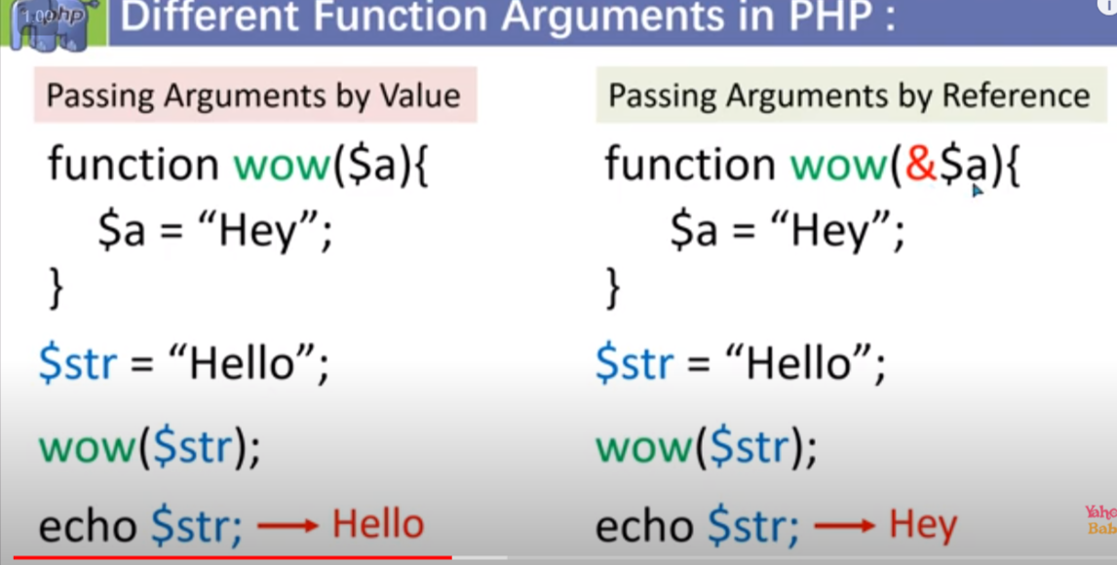

Note : with passing by refrence we can change the value itself in function . But we can not do this with the passing with the value we can not change the value .

Function declaration :

<?php

*function* wow($name){

    echo ("hello $name");

   }

   $fun="wow";

   $fun("Ajaj");

?>

Other way to define it is :

<?php

   $sayhello = *function*($name){

    echo ("hello $name");

   }; //remember to put semi-colen

   $sayhello("Ajaj");

   ?>

Global varible :

If we want to use global variable for that purpose we need to use global keywords .

<?php

   $a=15;

   $b=64;

*function* display(){

      global $a,$b;

      echo ("The value of a is : $a <br>");

      echo ("The value of b is : $b <br>");

   }

   display();

?>

* Array:

1.print_r() method :it is used to display array.

<?php

  $arr=[1,2,3,4,5,6,7,"Ajaj","Muskan","Anupam"];

  echo "<pre>";

  print_r($arr);

  echo "<pre/>";

?>

2.Assosiative array :if we want to give the name to ever index of array we can do that with the help of associative array.

ii) it is like key value pair.

<?php

  $age=["Ajaj"=>20,"Anupam"=>20,"Rudra"=>18,"Amanjeet"=>21];

  print_r($age);

  //or

  echo "<pre>";

  print_r($age);

  echo"<pre/>";

?>

Note : we can take any data types as key .

3.To know the data types of each index of array :

<?php

  $age=["Ajaj"=>20,"Anupam"=>20,"Rudra"=>18,"Amanjeet"=>21];

   //printing  the array

  echo "<pre>";

  print_r($age);

  echo"<pre/>";

   // fucntion for data types of each index

  var_dump($age);

?>

4.Foreach loop():

1.foreach loop with the assosiative array.

<?php

  $age=["Ajaj"=>20,"Anupam"=>20,"Rudra"=>18,"Amanjeet"=>21];

foreach($age as $key=>$value){

   echo ("$key=>$value <br>");

}

?>

2.foreach loop with the index array:

<?php

  $age=[20,20,18,21];

foreach($age as $value){

   echo ("$value <br>");

}

?>

5.1Multi dimensional index array :

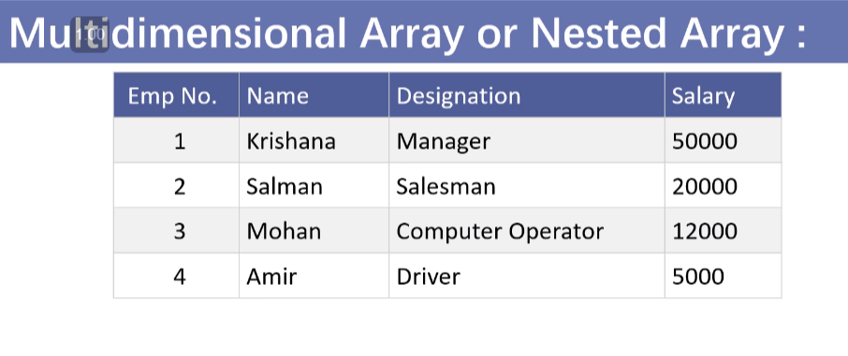

Syntax:

<?php

 $arr=[

   [1,"Krishana","Mangager",50000],

   [2,"Salman","Salesman",20000],

   [3,"Mohan","Computer operator",12000],

   [4,"Amir","Driver",5000]

 ];

 echo "<pre>";

print_r($arr);

?>

* 1. Loop with the multidimensional array :

a)for loop:

<?php

 $arr=[

   [1,"Krishana","Mangager",50000],

   [2,"Salman","Salesman",20000],

   [3,"Mohan","Computer operator",12000],

   [4,"Amir","Driver",5000]

 ];

 for($row=0;$row<4;$row++){

   for($col=0;$col<4;$col++){

      echo $arr[$row][$col]," ";

   }

   echo"<br>";

 }

?>

b)foreach loop :

<?php

 $arr=[

   [1,"Krishana","Mangager",50000],

   [2,"Salman","Salesman",20000],

   [3,"Mohan","Computer operator",12000],

   [4,"Amir","Driver",5000]

 ];

 foreach($arr as $row){

   foreach($row as $col){

      echo $col," ";

   }

   echo "<br>";

 }

?>

1.3. Converting multidimensional array int table:

<?php

 $arr=[

   [1,"Krishana","Mangager",50000],

   [2,"Salman","Salesman",20000],

   [3,"Mohan","Computer operator",12000],

   [4,"Amir","Driver",5000]

 ];

 echo "<table border='2px' cellspacing='0' cellpadding='10px'>";

 echo "<tr>";

 echo "<td>Emp no </td>";

 echo "<td>Name</td>";

 echo "<td>Designation</td>";

 echo "<td>Salary</td>";

 echo "</tr>";

 foreach($arr as $row){

   echo "<tr>";

   foreach($row as $col){

      echo "<td> $col </td>";

   }

   echo "</tr>";

 }

 echo "</table>";

?>

5.2.Multidimensional assosiative array:

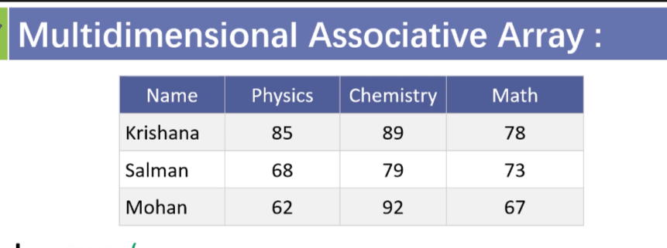

a) syntax:

<?php

   $student=[

      "Krishana"=>

      ["physics"=>85,

      "Chemistry"=>89,

      "Maths"=>78

      ],

      "Salman"=>

      ["physics"=>68,

      "Chemistry"=>79,

      "Maths"=>73

      ],

      "Mohan"=>

      ["physics"=>62,

      "Chemistry"=>92,

      "Maths"=>67

      ]

   ];

   echo "<pre>";

   print_r($student);

   echo "<pre/>";

?>

b).foreach loop in multi-dimensinoal array :

<?php

   $student=[

      "Krishana"=>

      ["physics"=>85,

      "Chemistry"=>89,

      "Maths"=>78

      ],

      "Salman"=>

      ["physics"=>68,

      "Chemistry"=>79,

      "Maths"=>73

      ],

      "Mohan"=>

      ["physics"=>62,

      "Chemistry"=>92,

      "Maths"=>67

      ]

   ];

   foreach($student as $student_name=>$value){

      echo $student_name ," ";

      foreach($value as $info){

         echo $info," ";

      }

      echo "<br>";

   }

?>

c) in table form :

<?php

   $student=[

      "Krishana"=>

      ["physics"=>85,

      "Chemistry"=>89,

      "Maths"=>78

      ],

      "Salman"=>

      ["physics"=>68,

      "Chemistry"=>79,

      "Maths"=>73

      ],

      "Mohan"=>

      ["physics"=>62,

      "Chemistry"=>92,

      "Maths"=>67

      ]

   ];

   echo "<table border='2px' cellpadding='10px', cellspacing='0'>";

   echo "<tr border='2px'>";

   echo "<td> Name </td>";

   echo "<td> Physics </td>";

   echo "<td> Chemistry </td>";

   echo "<td> Math </td>";

   echo"</tr>";

   foreach($student as $student_name=>$value){

      echo "<tr>";

      echo "<td> $student_name</td>";

      foreach($value as $info){

         echo "<td>$info</td>";

      }

      echo "</tr>";

   }

   echo "</table>";

?>

6. FOREACH WITH THE LIST :

a)syntax:

<?php

   $arr=[

      [1,"Krishana","Mangager",50000],

      [2,"Salman","Salesman",20000],

      [3,"Mohan","Computer operator",12000],

      [4,"Amir","Driver",5000]

    ];

    foreach($arr as list($id,$name,$designation,$salary)){

      echo "$id $name $designation $salary"."<br>";

    }

?>

b) in table form:

<?php

   $arr=[

      [1,"Krishana","Mangager",50000],

      [2,"Salman","Salesman",20000],

      [3,"Mohan","Computer operator",12000],

      [4,"Amir","Driver",5000]

    ];

    echo "<table border='2px',cellpadding='10px' ,cellspacing='0px'>";

    echo "<tr>";

    echo "<td>id</td>";

    echo "<td>Name</td>";

    echo "<td>Designation</td>";

    echo "<td>Salary</td>";

    echo "</tr>";

    foreach($arr as list($id,$name,$designation,$salary)){

      echo "<tr>";

      echo "<td>$id</td>";

      echo "<td>$name</td>";

      echo "<td>$designation</td>";

      echo "<td>$salary</td>";

      echo "</tr>";

    }

    echo "</table>";

?>

7.Arrays size methods :

a)count() // give size

b)sizeof() // give size

3)array_count_values()

Eg of array_count values():

<?php

  $arr=['orange','apple','graphs','banana','orange','watermelon','graphs'];

  echo "<pre>";

  print_r(array_count_values($arr));

  echo "<pre/>";

?>

Output:

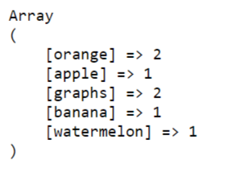

8. Array search method :

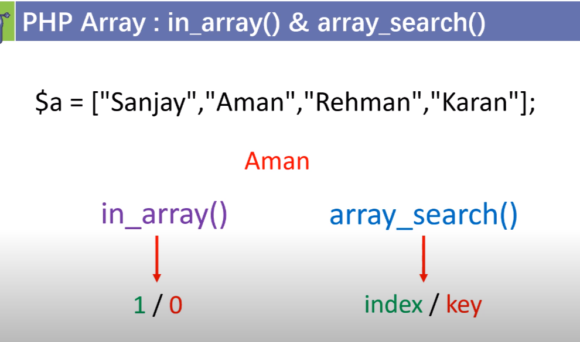

a)in_array(search_value,array_name);

we can use strict mode as well : like if I am searching for array it should not give string value : eg :

<?php

  $arr=['orange','apple','graphs','banana','orange','watermelon','graphs' ,"55"];

 echo in_array(55,$arr,true);

?>

b) array_search(serach_value,array_name);

9.Array replace method :

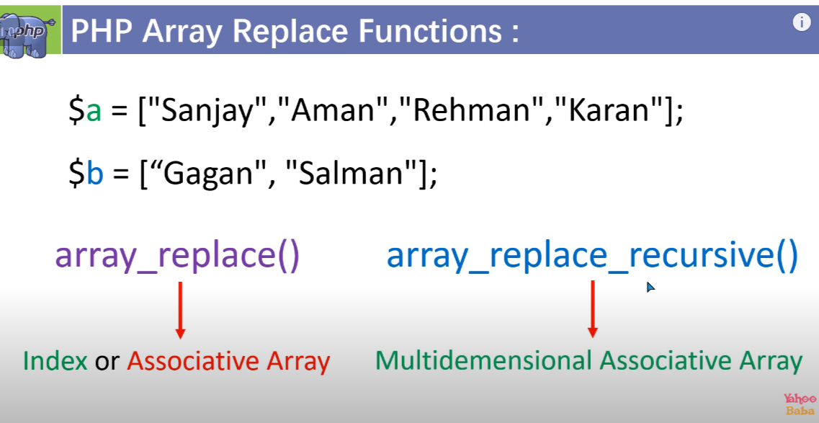

Note : it will give a new array not going to change the existing array.

Array_reaplace(original_array/orginal_array_index,array/value we want to replace to)-+

<https://www.youtube.com/watch?v=_lix9Hfp8AI&list=PL0b6OzIxLPbyrzCMJOFzLnf_-_5E_dkzs&index=41>

10.Array push() or pop()

<?php

 $fruits=["mango","watermelon","Graphs","oranges","Apple"];

 echo "<pre>";

 print_r($fruits);

 echo "<pre/>";

 array_pop($fruits);

 echo "<pre>";

 print_r($fruits);

 echo "<pre/>";

 array_push($fruits,"Apple");

 echo "<pre>";

 print_r($fruits);

 echo "<pre/>";

 ?>

Note : with the array_push we can push multiple element eg :

 array_push($fruits,"Apple","Guva","strawberry");

11.array_Shift() and array_unshift()

Array_shift() :remove element from beginning .

array_unshif() :add element from the beginning .

note : we can do multiple entry with the array_unshift()

12. array_merge() or array_combine() or array_merge_recursively()

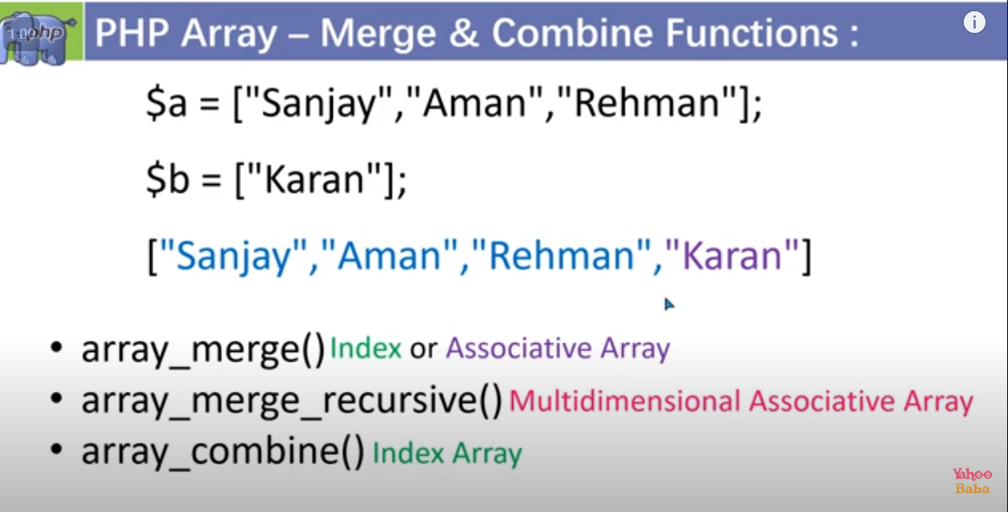

Note : i)All of these will going to give a new array . ii)syntax : $new_var=array_merge($arr1,$arr2)

iii) we can mege more than two array with the array_merge or array_combine method()

iv) on merging assosiative array if they have same key then it will going to overwrite with the last value.

v) in case of multi dimensional array if we use array_merge_recurrsive() if there is two same key then it will not going to overwrite instead it will going to make a another subarray with the all common element with the same common key .

array_combine :

in array combine it will going to combine only index array. The two array should have same no of element . it will going to make the first array as a key and the second array as value .

<?php

 $fruits=["mango","watermelon","Graphs","oranges","Apple"];

 $no=[1,2,3,4,5];

 $new_arr=array_combine($no,$fruits);

 echo "<pre>";

 print_r($new_arr);

 echo "<pre/>";

 ?>

Output :

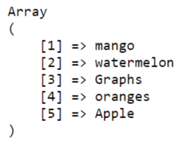

13.array_slice():

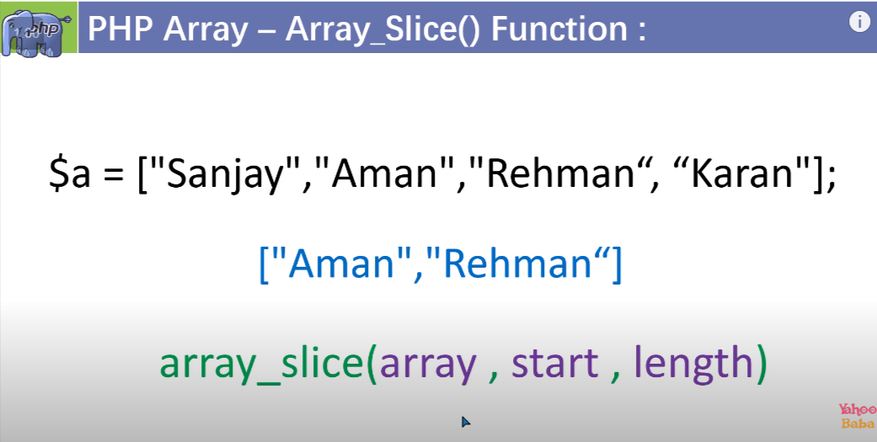

Note : we can give negative index for start as well if we want to slice it from the ending .

ii) in slicing if we want the current key should remain as a the current key the we can use true as a forth parameter.

iv) this genrally use in slicing the assosiative array . forth parameter is called preserved value.

<?php

 $fruits=["mango","watermelon","Graphs","oranges","Apple"];

 $new_arr=array_slice($fruits,3,2,true);

 echo "<pre>";

 print_r($new_arr);

 echo "<pre/>";

 ?>

14.array_splice():

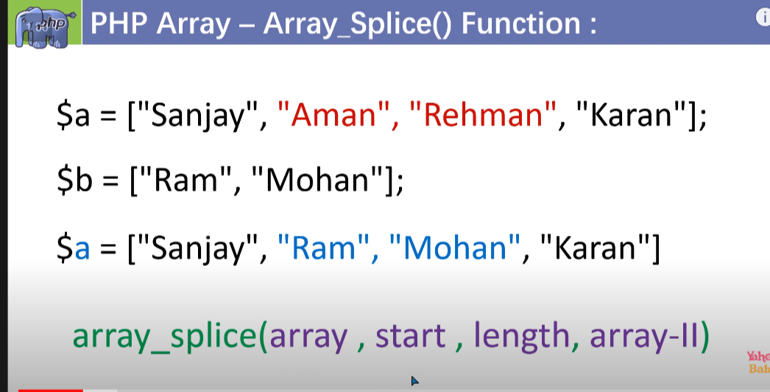

Note : we can use this to delete some element from the existing array.

ii)it will not going to form a new array it will perform the operation on the existing array.

iii)we can also use negative indexing as well.

15.array_key function;

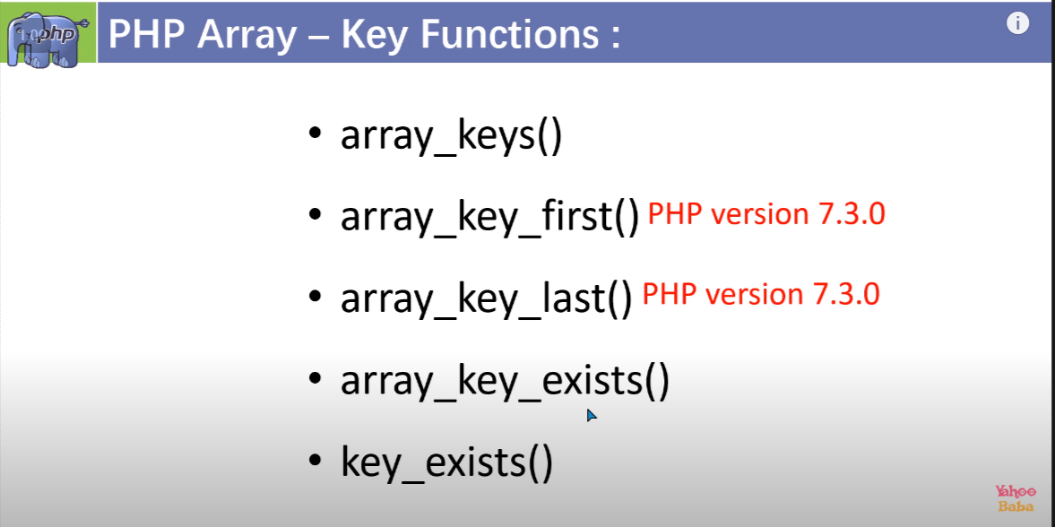

Note : array_keys() : it will going to return a new array with element as keys.

ii) array_key_exists(value,$array_name)

16.array_intersect()

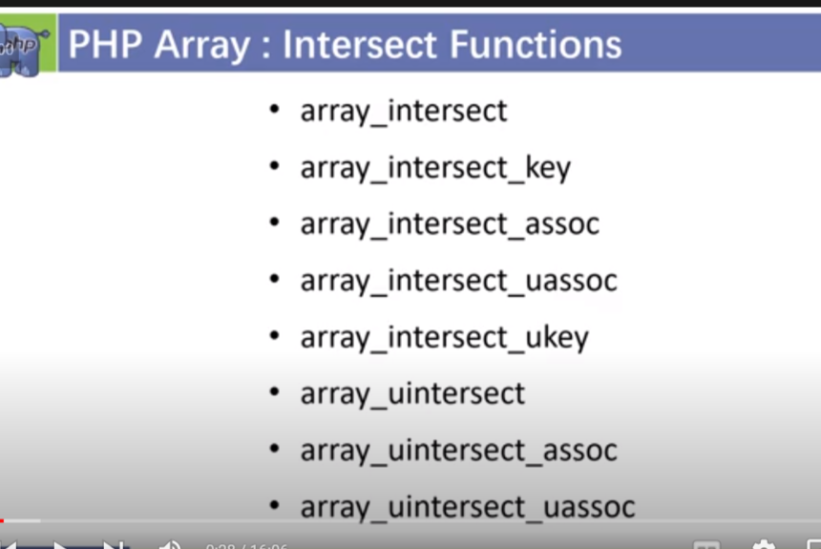

Note we can use intersect for two or more than two array .

1. If we want common value then we use : array_intersect() , the key will be the keys of first array of input
2. If we want common value then we use :array_intersect_key() ;
3. If we want common key and value then we use array_intersect_assoc() , assoc means associative .
4. Array_intersect_uassoc(); it will going to take user define function as a theird parameter and compare both keys and function.

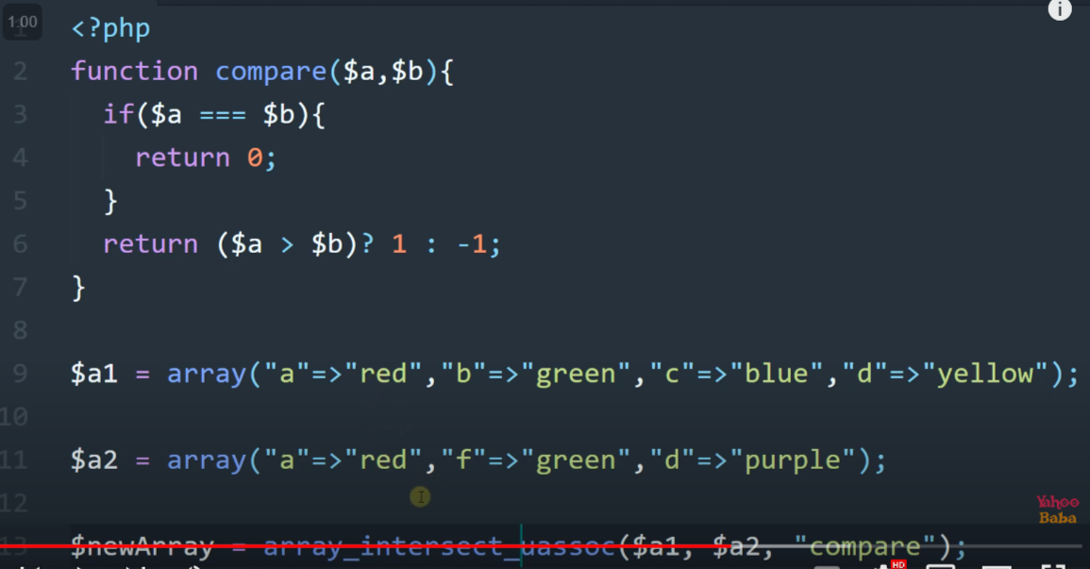

1. Array_uintersect() ; it will going to take theird parameter as a user define function and only compare values
2. Array_intersect_ukey() : it will going to take user define function as a theird parameter and compare only keys.
3. Array_uintersect_uassaoc():it will going to take user define function to compare key as a theird parameter and user define function to compare values as a fourth parameter .

17. array_diff():it will going to find a new of which different value from two or more different array

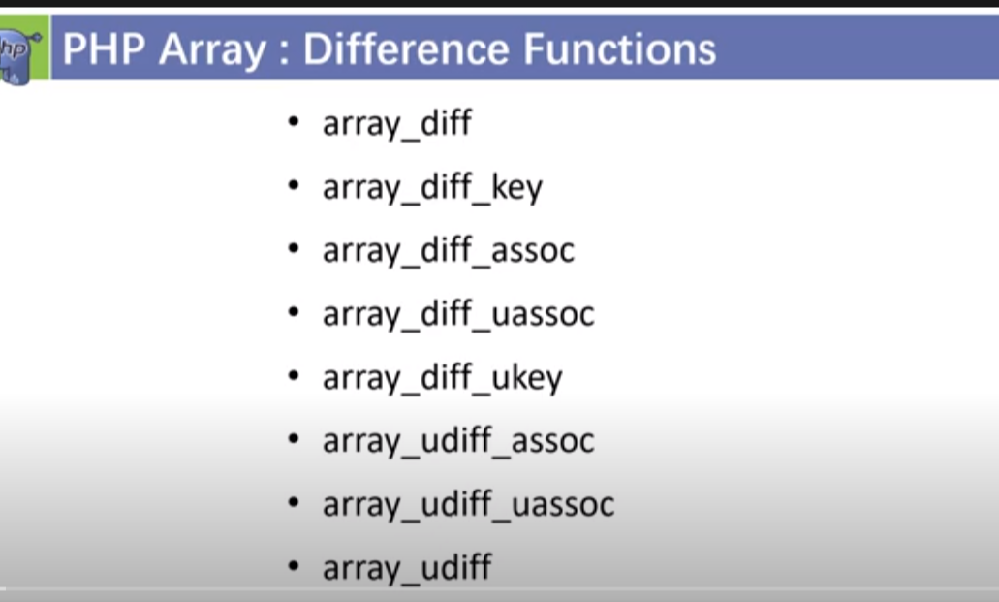

18.

I)array_values() :it will going to give a new array which consist only values.

iii)array_unique():it will going to give a new array with the unique value and key will be the key of first find value which is repeating in the array.

19.

If we want to make a new array from multidimensional array with the common field for that we can use :

i)array_column($multidimensinoal_array_name,field_name_under_invertedcoma);

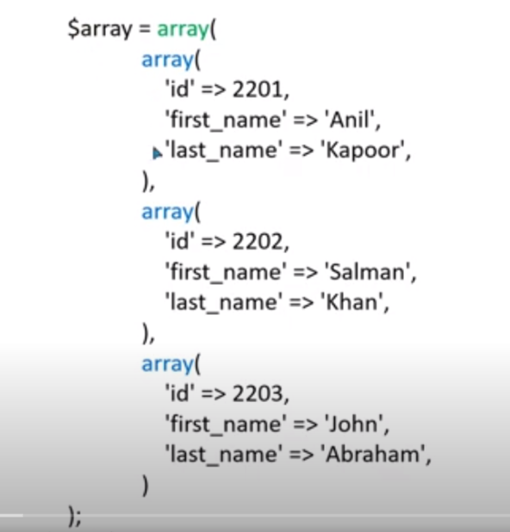

ii) for making a associative array we need to pass the another field name as a theird parameter which will be key and second parameter will be value) in array_column($multidimensional_array_name,”value_field_name”,”key_field_name”);

19.2)array_chunk():

If I want to make a multidimensional array from the for 1d array we can use array_chunk()

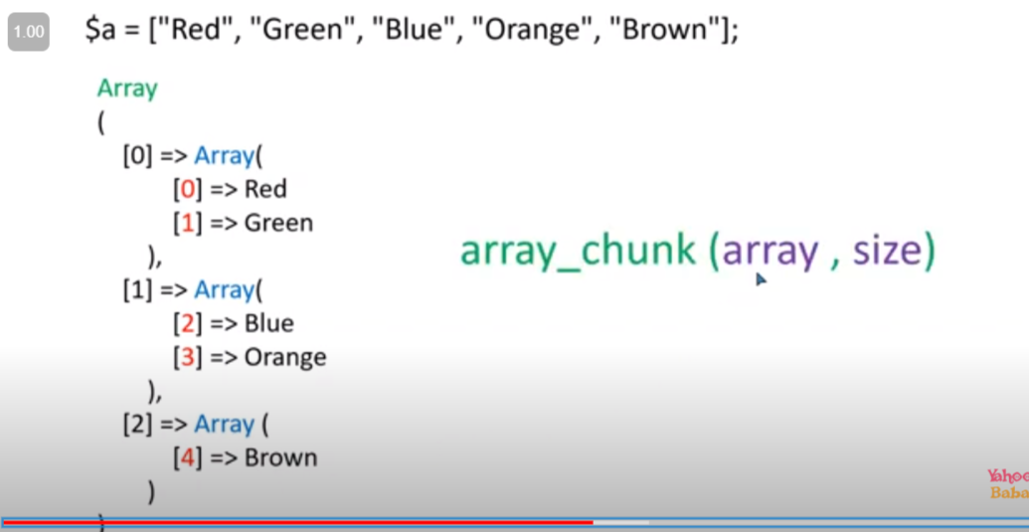

For assosiative array if we want to retain the their orginal key other wise it will going to give key as 0,1,2…… then we need to use true(preserve_value) as a theird parameter.

20.array_flip():

In associative array if we want to flip key to values and values to key for that we need to use array_flip()

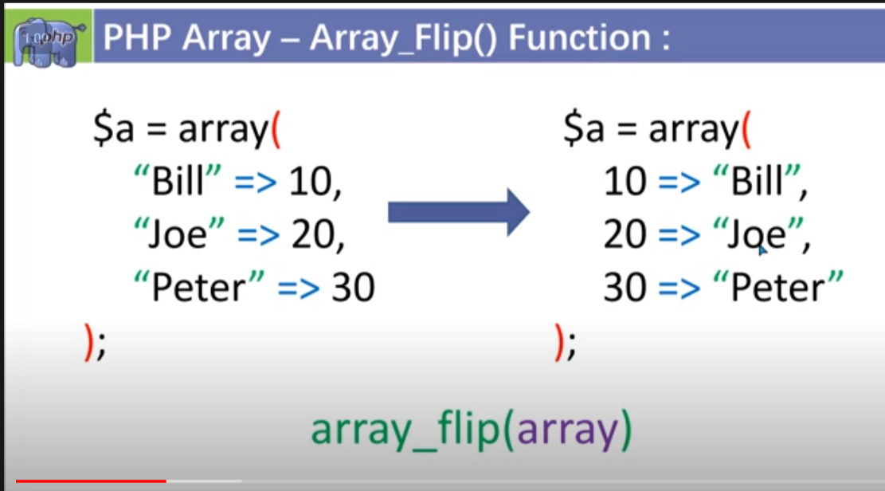

20.1) if we want to change the case of the key for that we can use array_case() method

Note : in place of case we need to write CASE_UPPER/CASE_LOWER

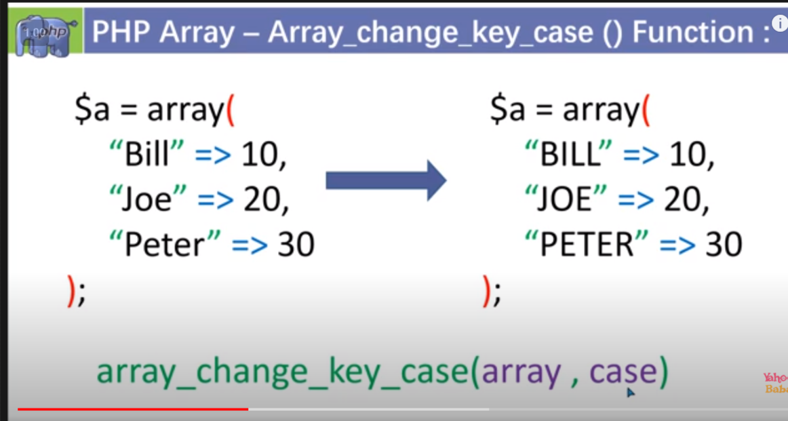

21.array_sum():

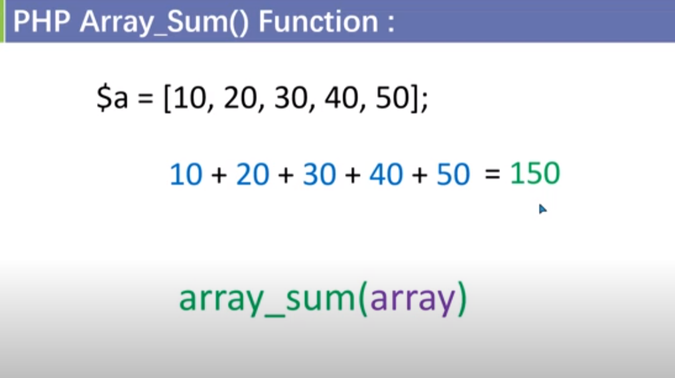

21.2)array_product():

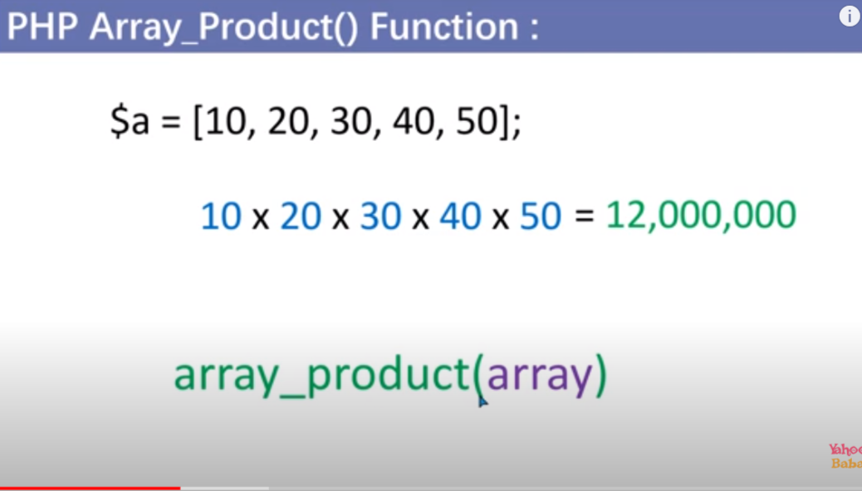

Note : it will going to work with the assosiative array as well , it will going to sum/product the value only of associative array.

22.array_rand():

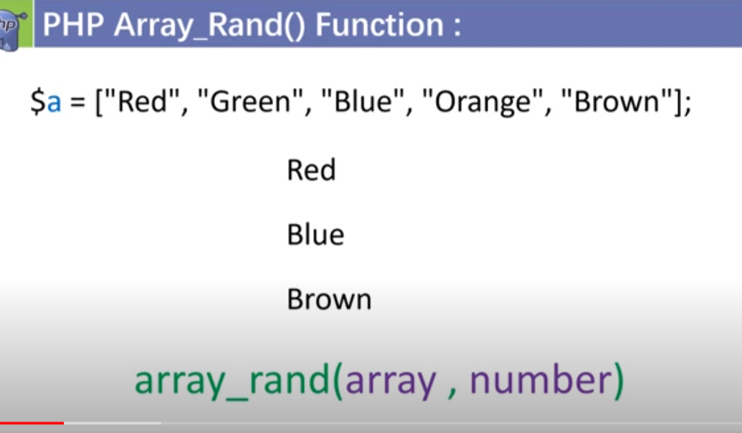

Note:number is the no of value we want as random display . if we not mentioning any no then by default it will going to display 1 element only.

22.1)array_shuffle():

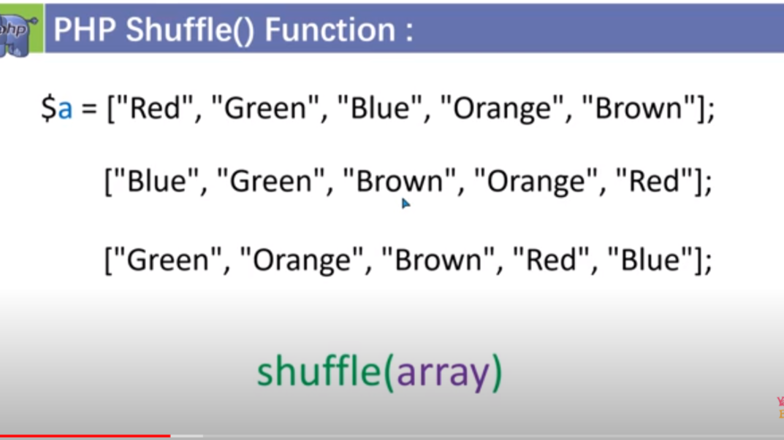

Note : it will apply the shuffle property on the existing array there will be no new array formation.

23.array_fill_key() and array_fill();

23.1)array_fill_key():

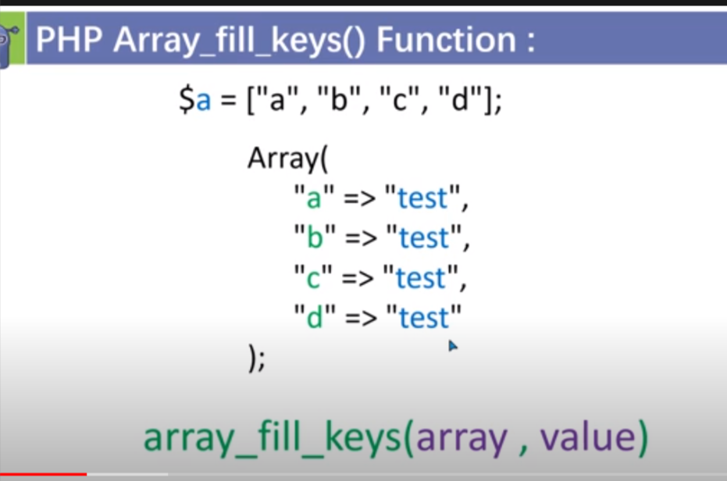

23.2)array_fill():

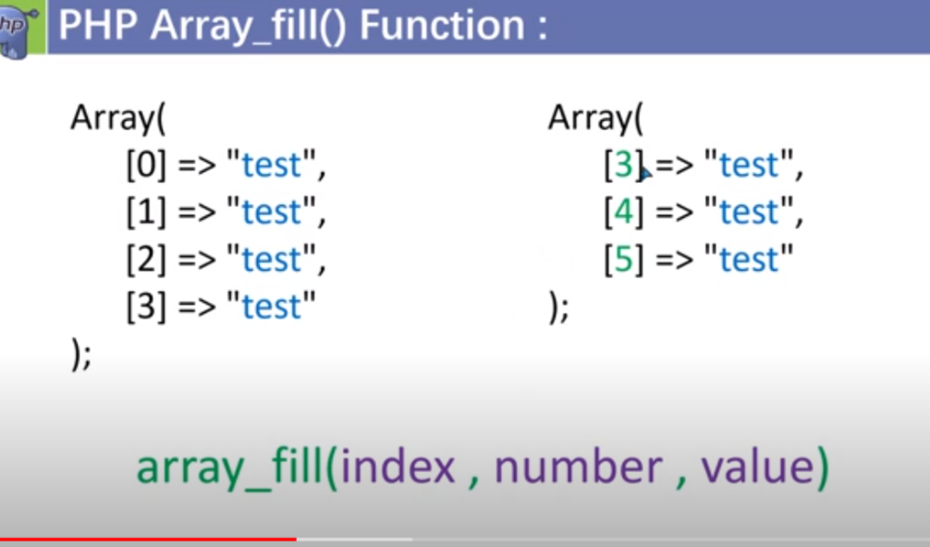

24.array_walk():it used for index and associative array

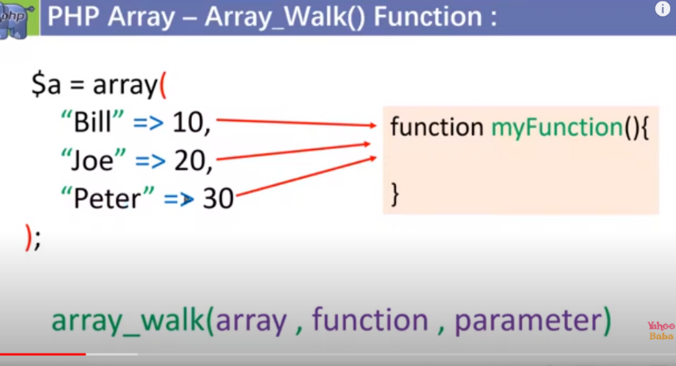 note parameter Is optional

24.2)array_walk_rercursive():it used for multidimensional array

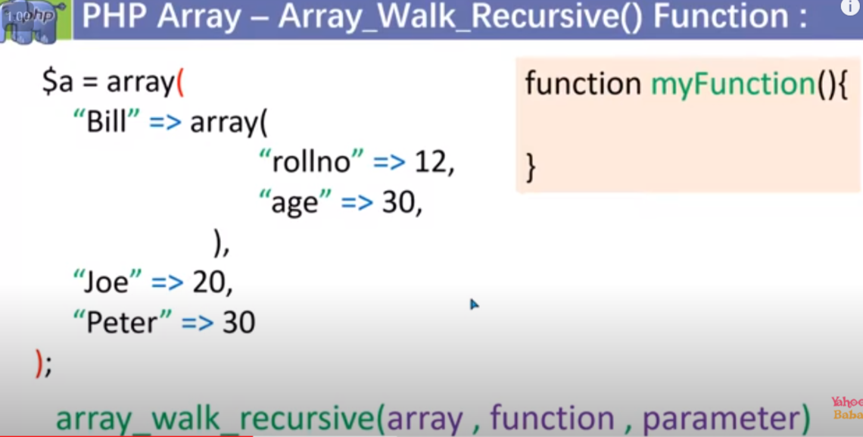

Code :

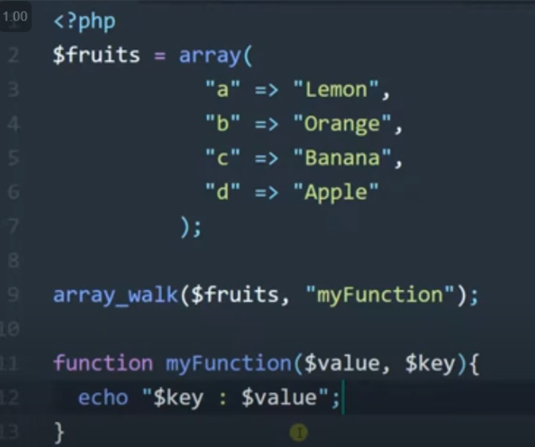

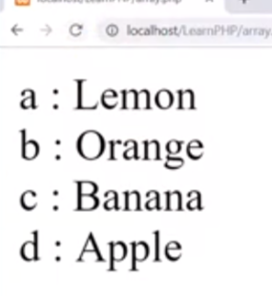 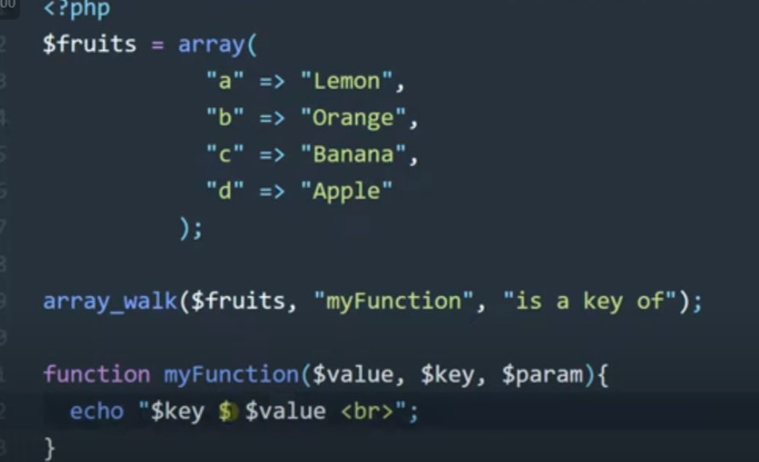

25.array_map():

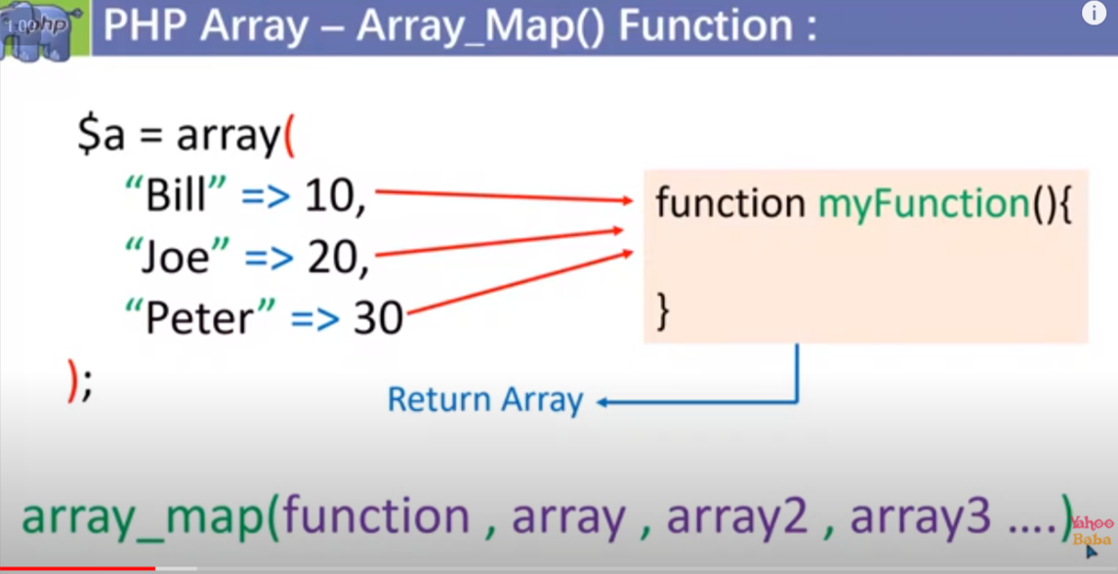

Note : it can take more than one array as well

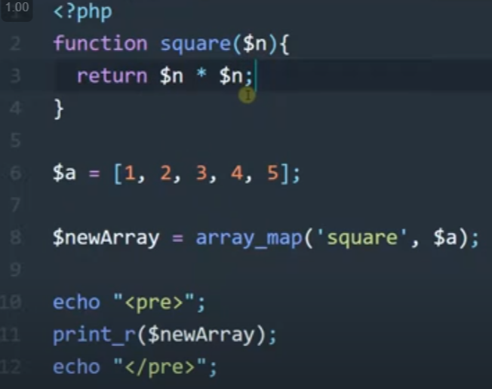

For more than one array :

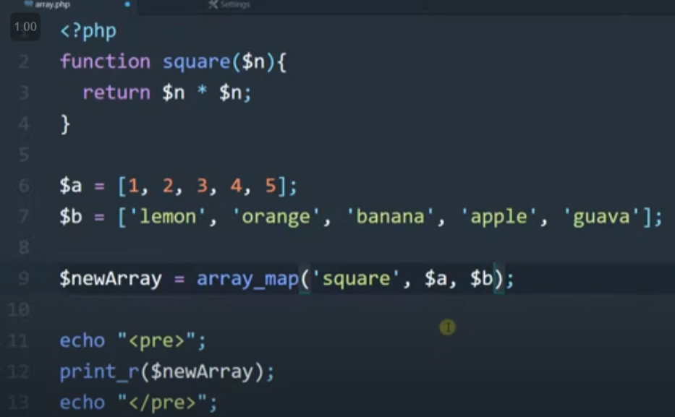

Difference between array_map and array_walk

i) array_map return something where as array_walk does not return any things

ii)array_map can be used for more than one array but the case is note same for array_walk

26.array_reduce():

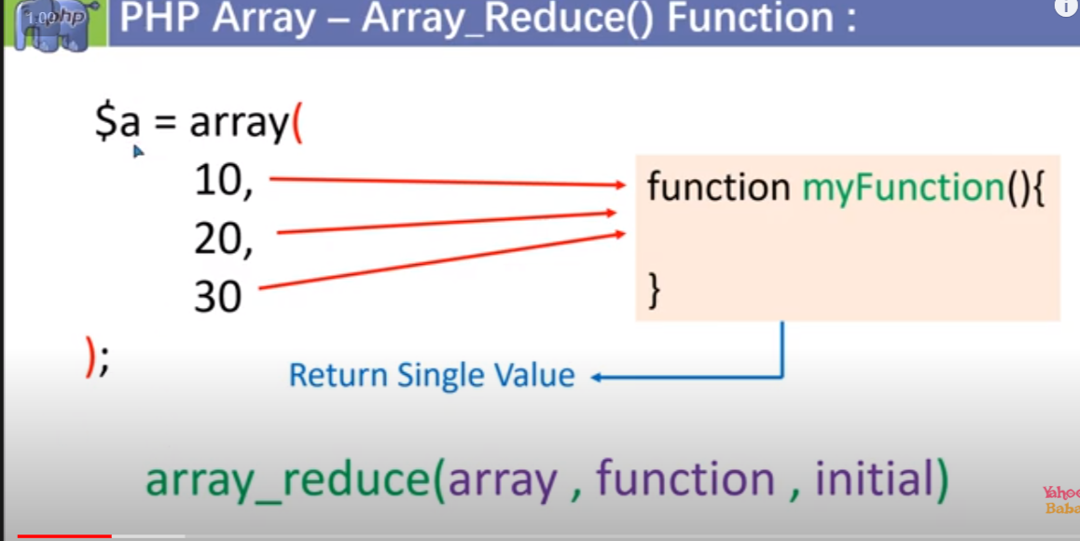

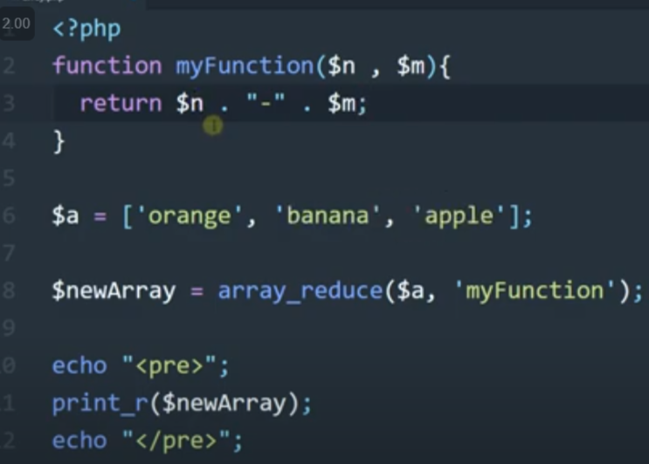

If I give any value as a therid argument then $n will automatically going to take the value .

27.sort method :

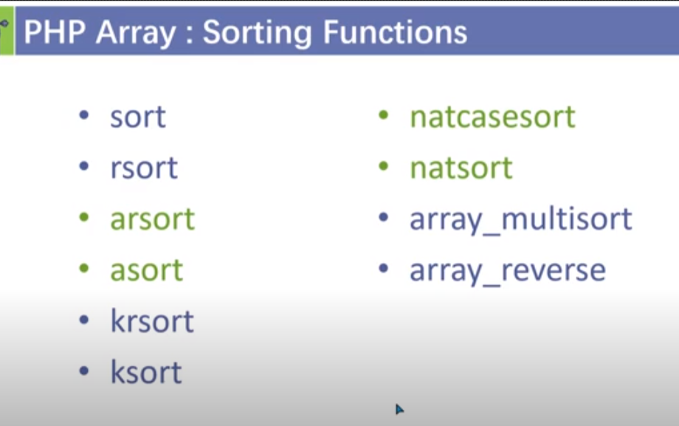

Note :

1) sort means : sort in ascending order and rsort means sorting in descending order . it will going to

ii)sort and rsort () : sort wrt to values .it will used to sort index array wrt to values.

iii) asort() arsort() :it will sort associative array wrt to value with the key visble.

iv)ksort() or krsort() : it will going to sort wrt to key .

v)natsort():means natural sort it will be used to sort given kind of things

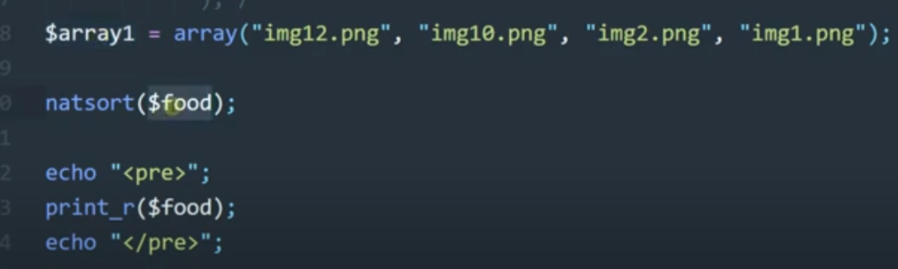

v)natcasesort():it will going to sort with respect with the case (uppercase/lowercase)

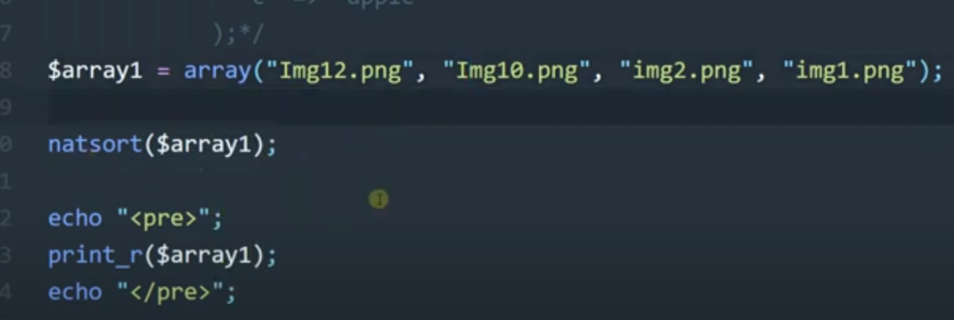

vi)multisort():it is used to sort multiple array at the same time . but the no of element should be the same in all arrays.

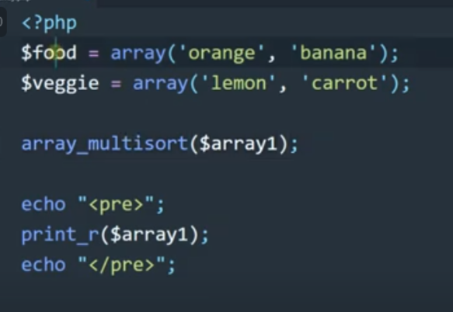

28.array_reverse() :

It will going to give a new array by reversing the element.

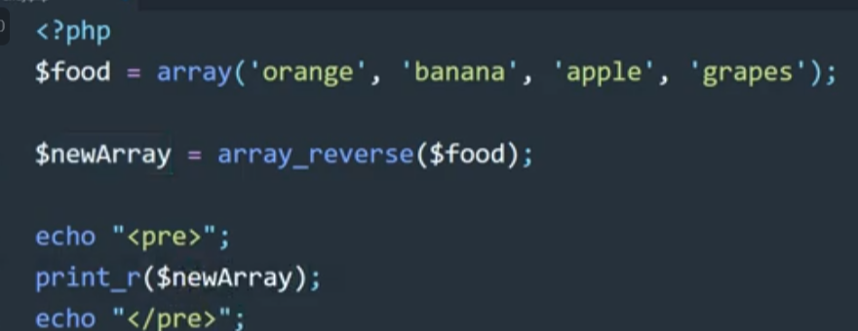

Note : it will going to reverse all kind of array eg : index array , associative array ,multi dimensional array .

29.array treversal :

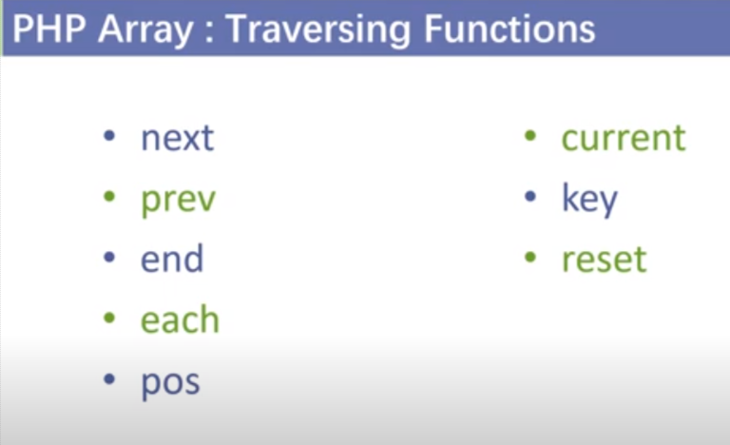

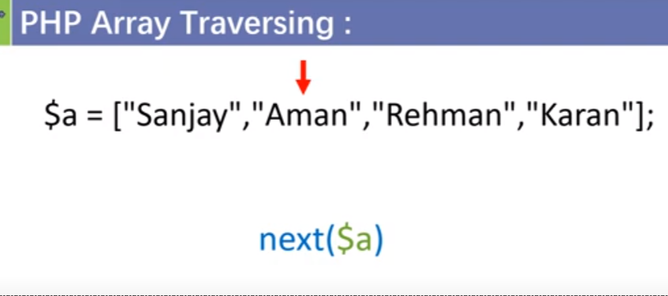

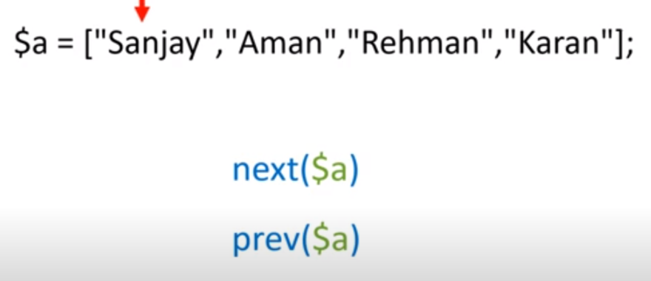

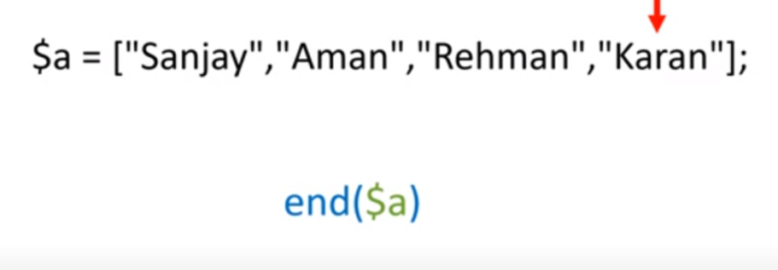

29.1)current(),key():current will going to give current value and key will going to give current key.

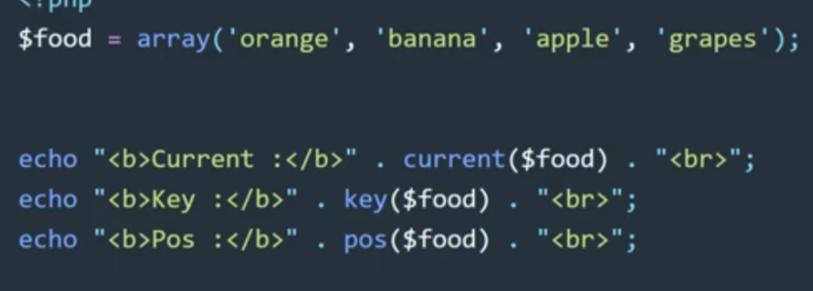

29.2)reset($array_name) :it will going to reset the pointer at the zero postion.

30.destructuring array : list():

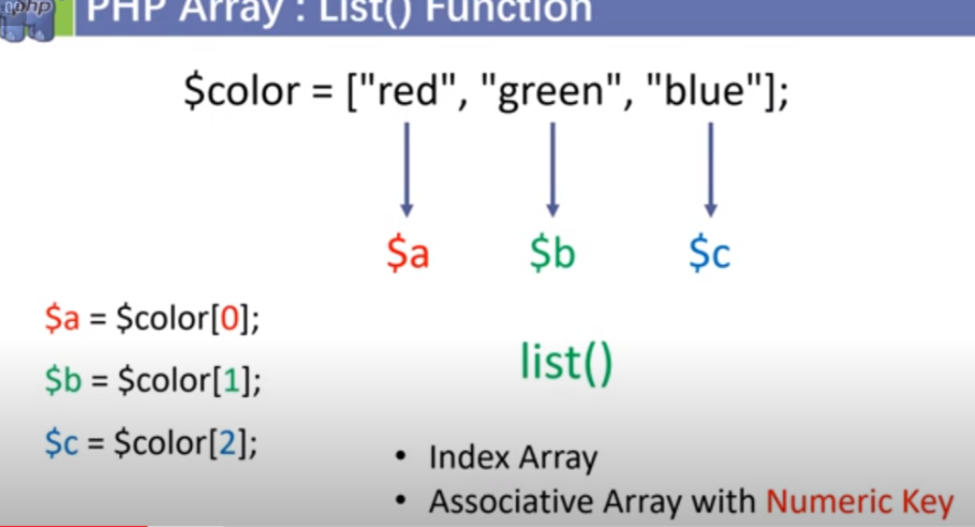

Syntax:

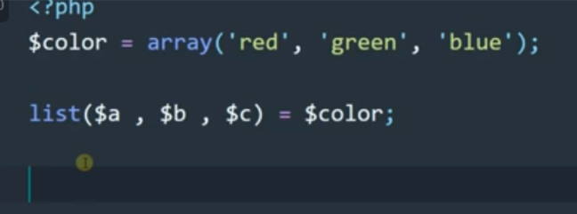

Note : we can also use it like skip value .

Eg:

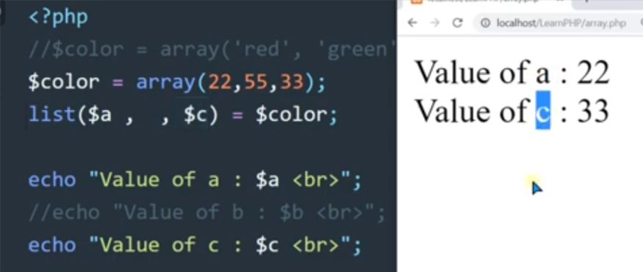

We can also create a new array with the selected value :

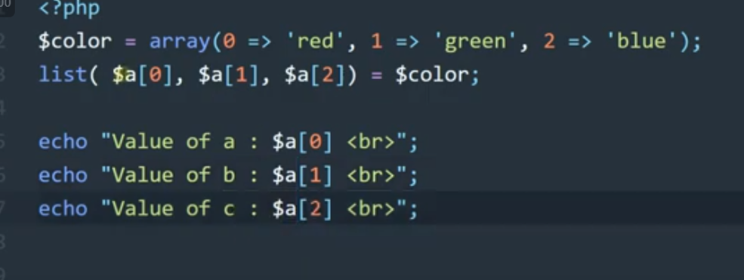

31.range():

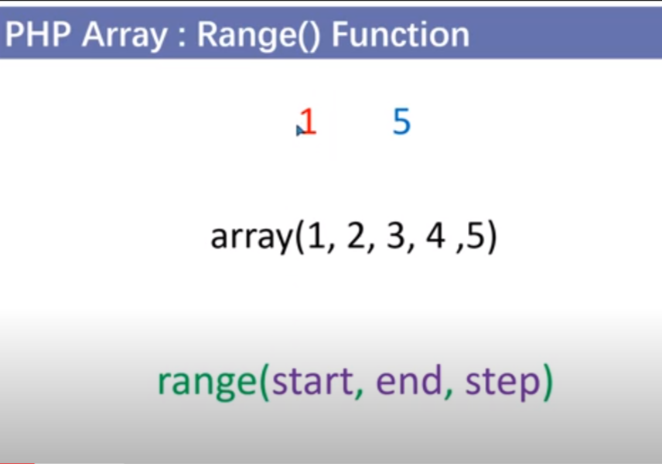

Note :

i)we can print alphabate value also.

ii)if we give range(5,1) : it will give 5,4,3,2,1 and same with the alphabate range(‘e’,’a’).

32. converting a string to array and vice-versa

1)explode:use to convert string into array

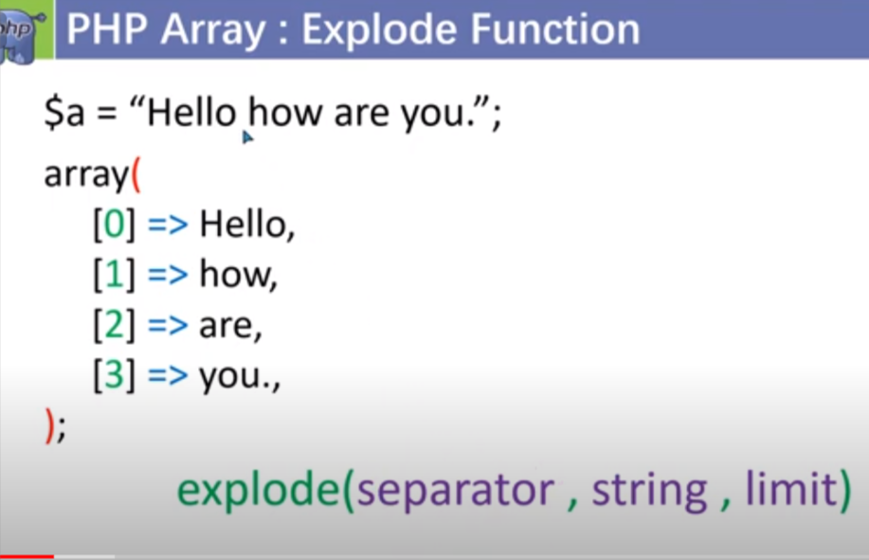

Note: limit is optional and it defines how no of array we want to make from the string .

Implode : use to convert a array into a string .

Note : we can use join also

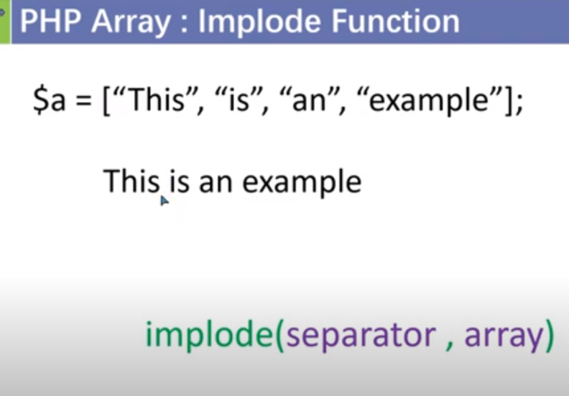

32.3)str_split():

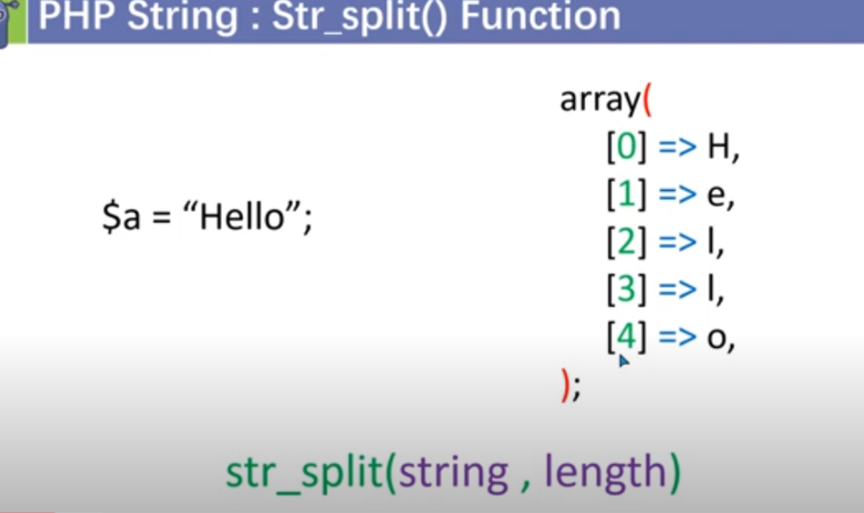

Note : length means no of letter we want to store at each index .by default length is 1;

String :

1. 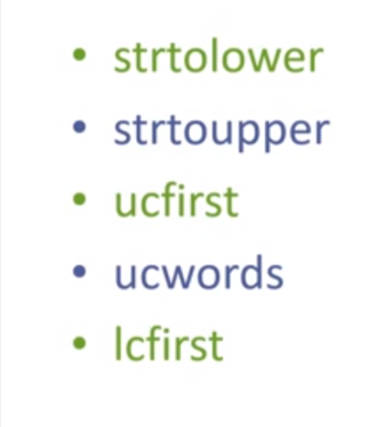

**Ucfirst:upper case first is used to upper case the first character of any string .**

**Ucword : upper case first character of every word in a string .**

**Lcfirst: lower case fist character of string .**

**Note : all of them will going to give a new string .**

**2.string length property**

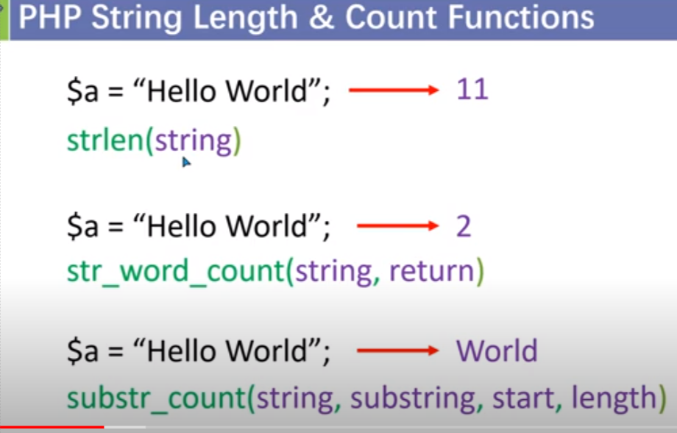

**3. string search :**

3.1) Case sensitive search :

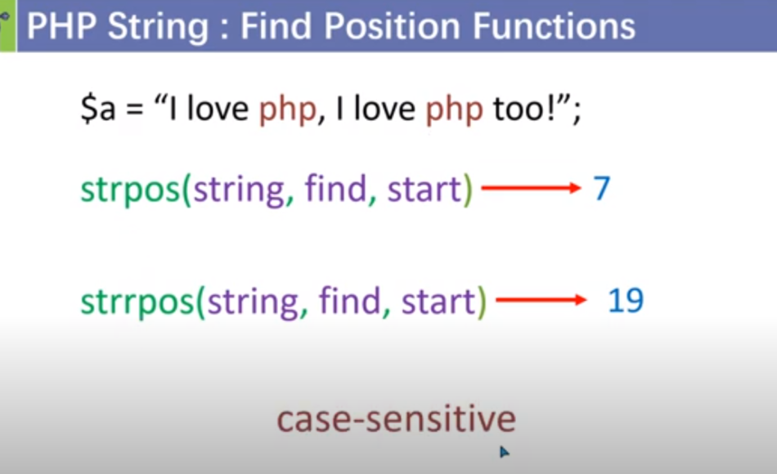

3.2) Case insensensitive search :

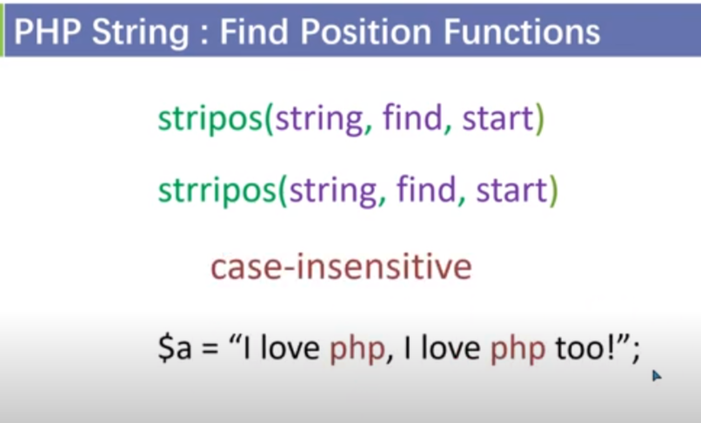

**4.sub_str():**

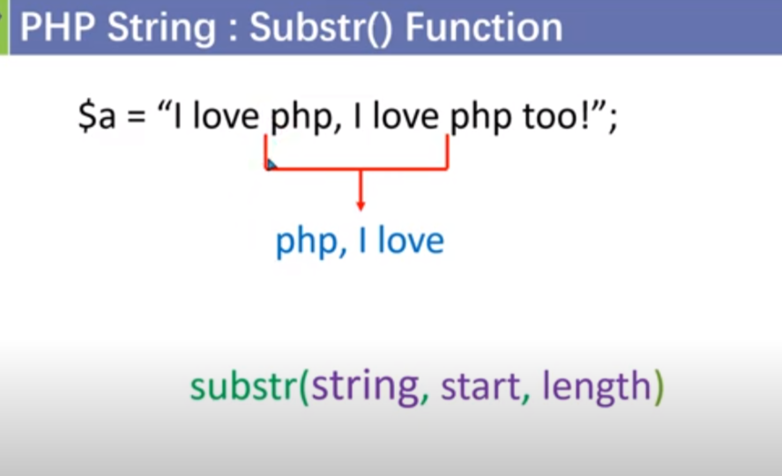

**5. str_replace :**

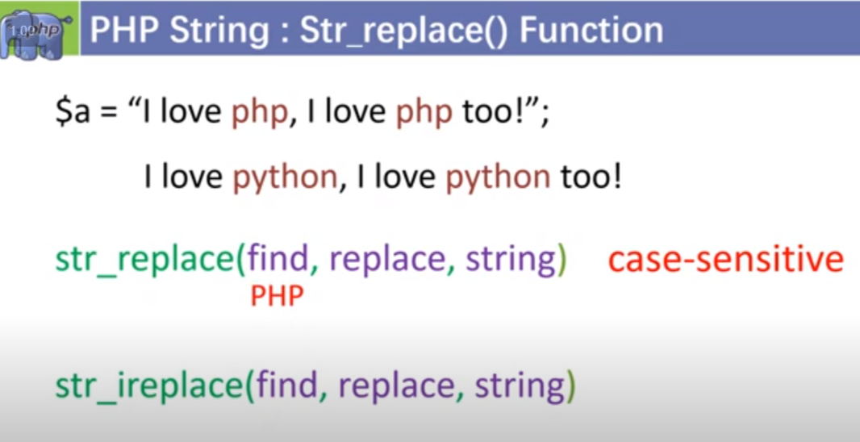

**6.str_rev():**

**Syntax : str_rev(str_name)**

**7. slash : it is used to protect our data from hacking when we are moving our data into the data base.**

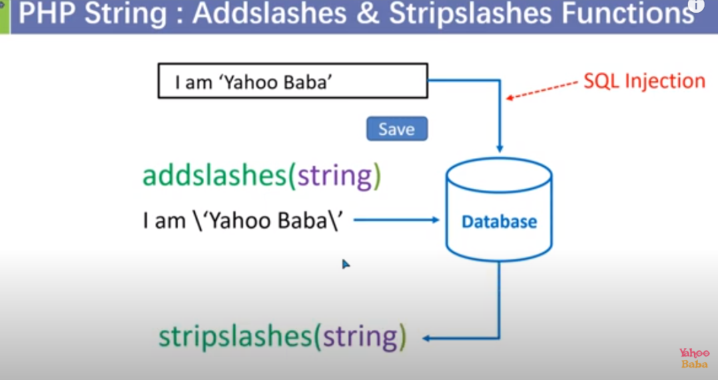

**Addslash:add slash at every single / double quote .**

**8.htmlentites :**

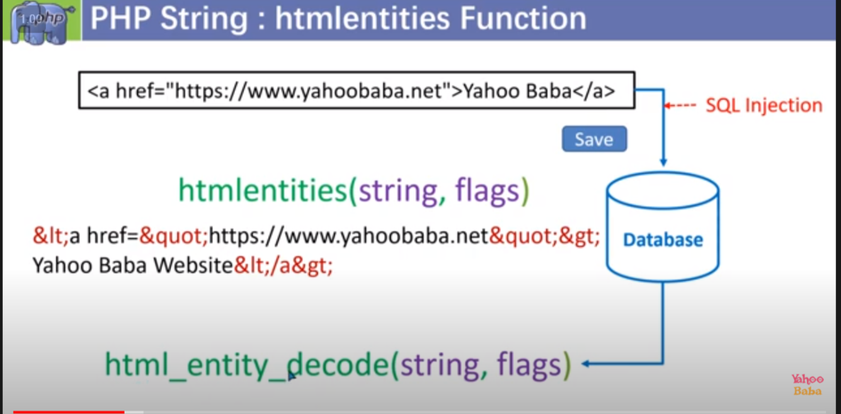

**Flage : input**

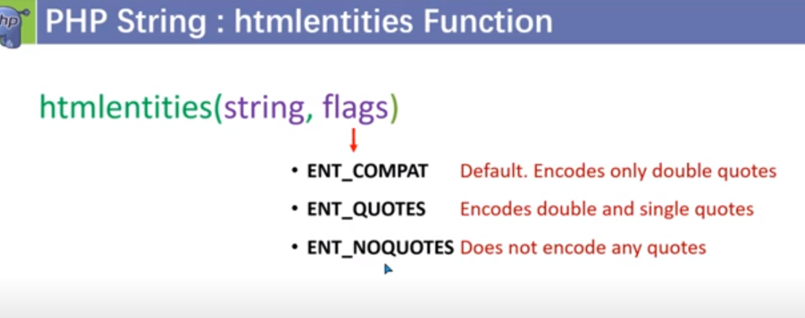

Entity code of special quote :

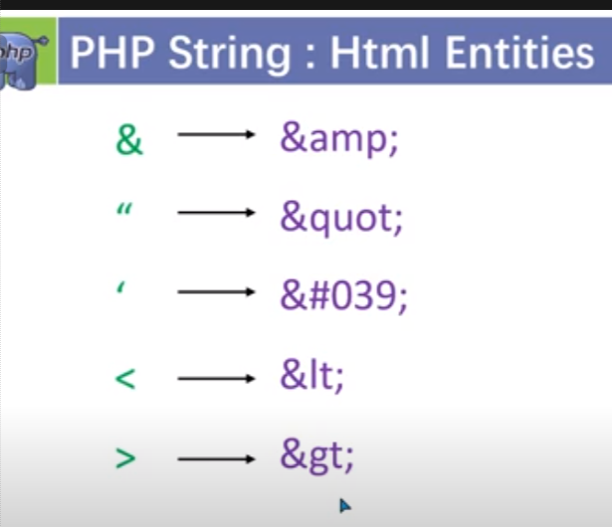

9.password encouroput :

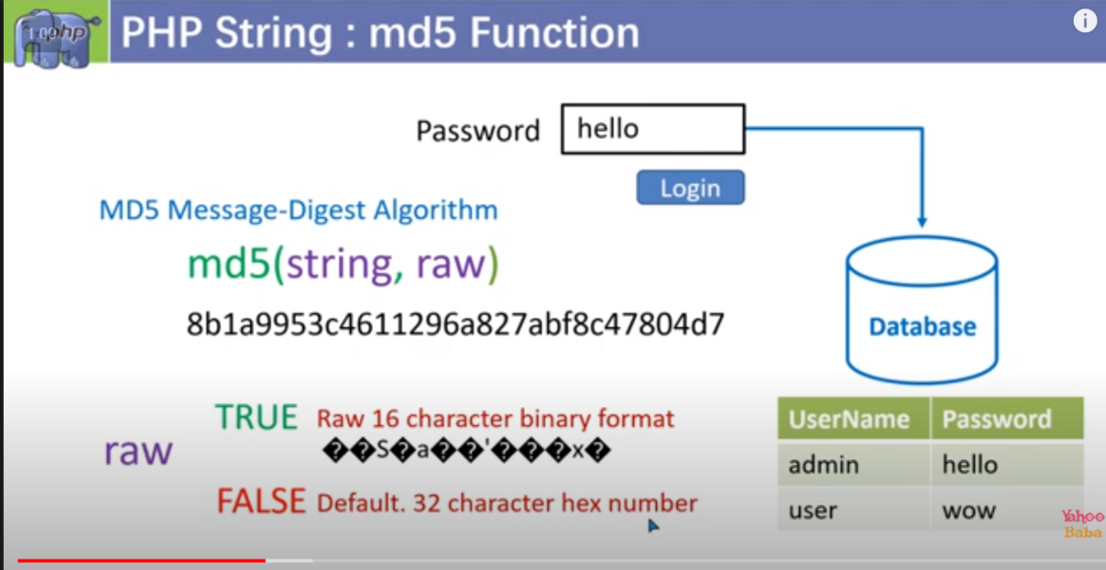

Note : by default raw value : false

Sha1 : it is work same as md5 but more secure than md5

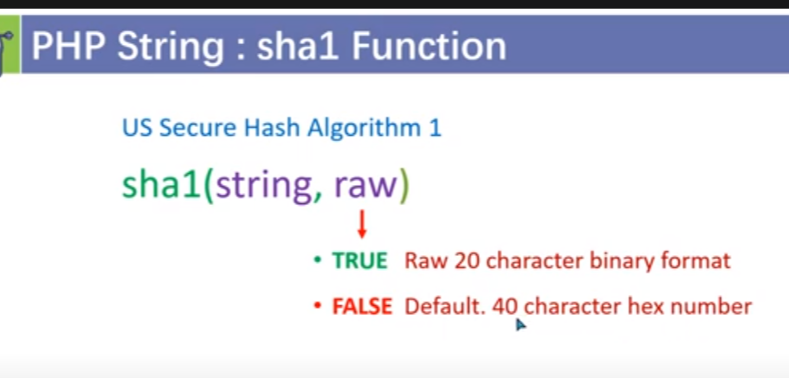

**10. to encrypt message :**

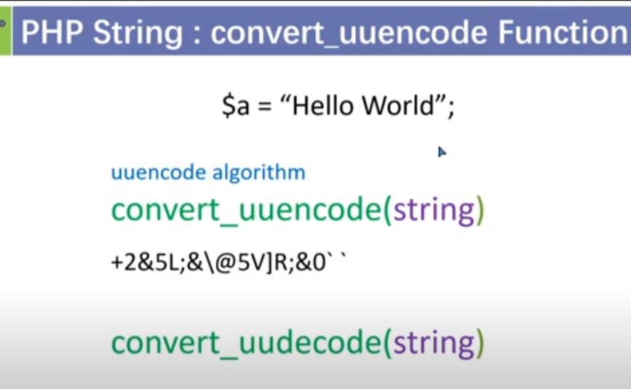

**11. bin2hex and hex2bin:**

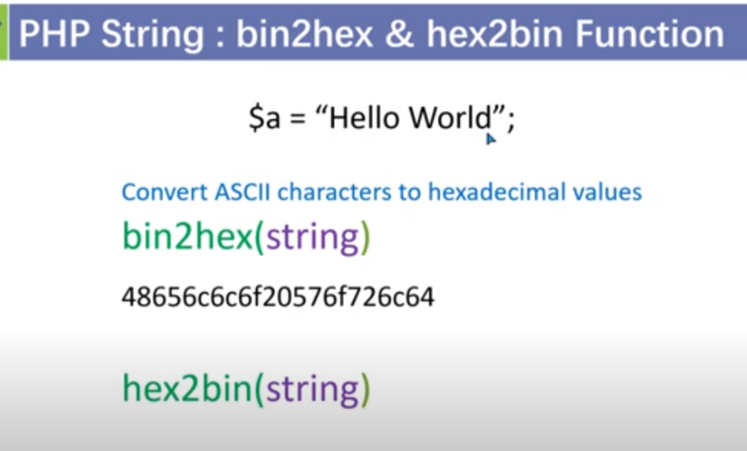

**12. strip_tags():**

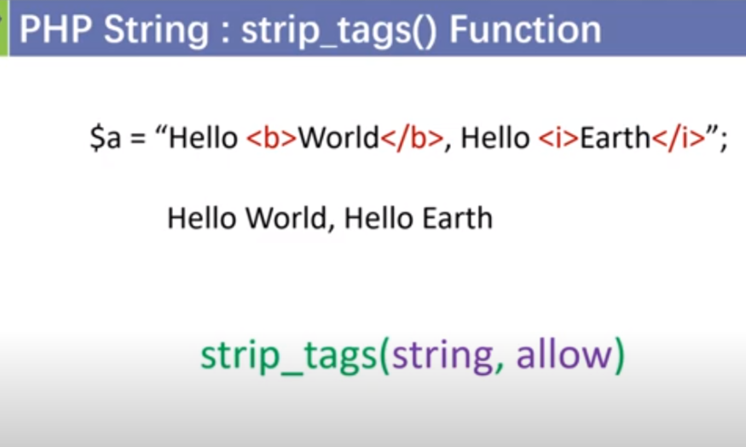

**Note : this will use if we donot want to apply any of particular tag in our string .**

**Math function :**

**1.min/max:**

**Note : it can be used with array as well .**

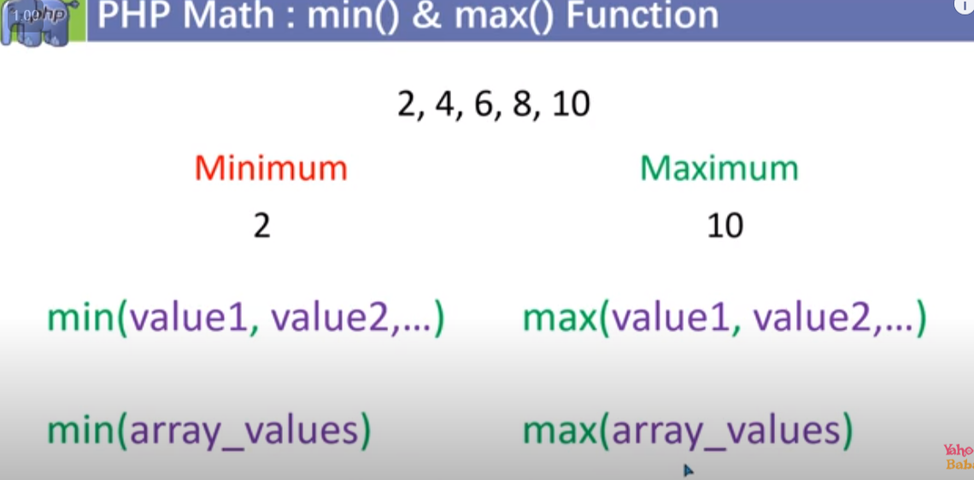

**2.abs(),floor(),ceil(),round()**

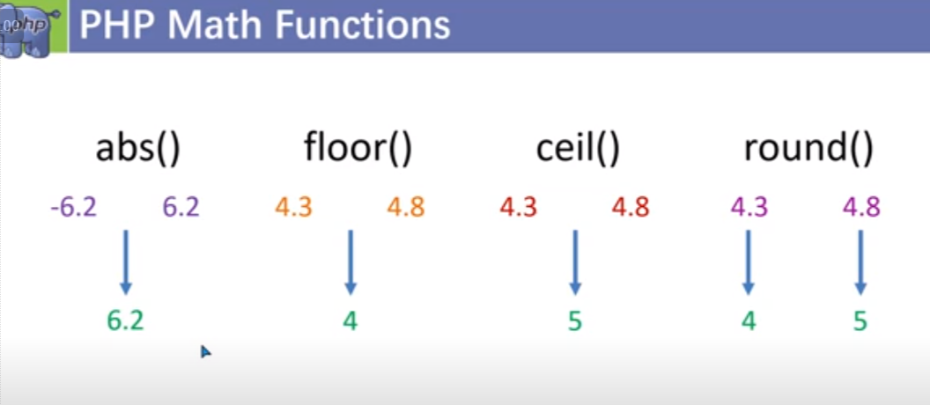

**3.indiv(),sqrt(),pow():**

**A) inddiv(divisor,dividend)**

**b)pow(base,power)**

**c)sqrt(value)**

**4. rand(min_value,max_value) : it will going random integer between min_value and max_value .**

**Date function () : format in**

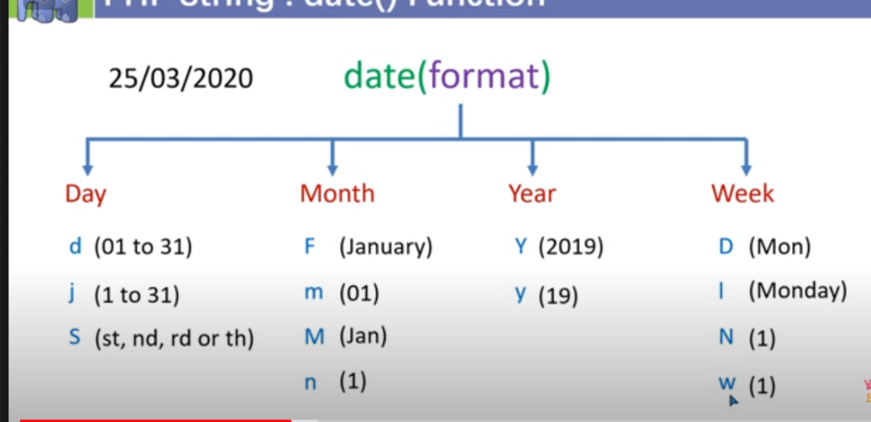

<?php

echo "current date is :".date("jS-M-Y");

 ?>

**Time function () :**

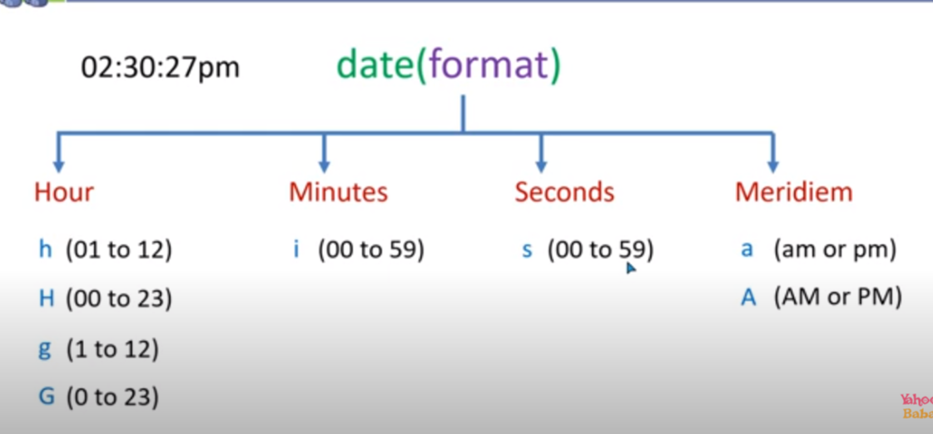

**Eg :**

<?php

echo "current date is :".date("jS-M-Y")."<br>";

echo "current Time is :".date("h:i:s A")."<br>";

 ?>

**To get past time :**

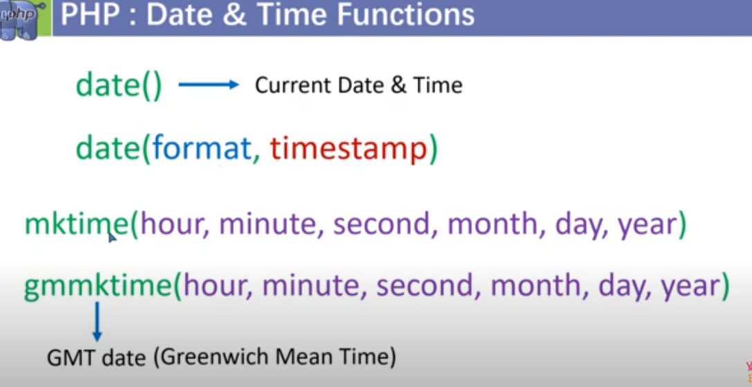

<?php

echo "day on 1st jan 1998 :".date("D",mktime(0,0,0,1,1,2000));

 ?>

**To show the future date and time :**

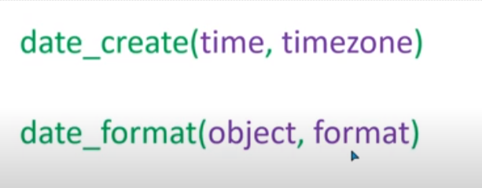

<?php

$future_date=date_create("01-01-2024 ");

echo "future day on future date is: ".date_format($future_date,"D");

 ?>

**Note we can also pass time as well :**

<?php

$future_date=date_create("01-01-2024 07:45:12 AM");

echo "future day on future date is: ".date_format($future_date,"D h:i:s: A");

 ?>

**Date modification :**

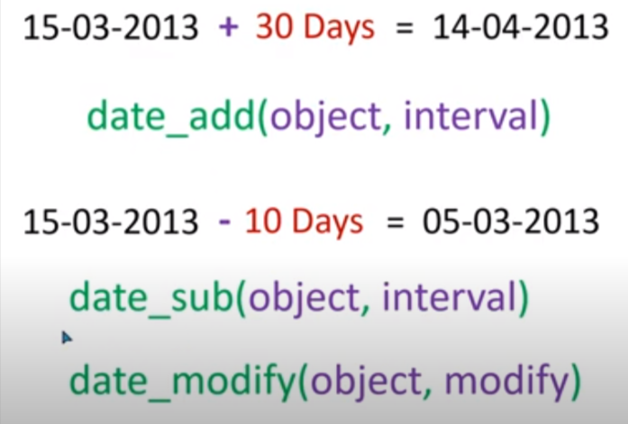

**Note : object will be existing date**

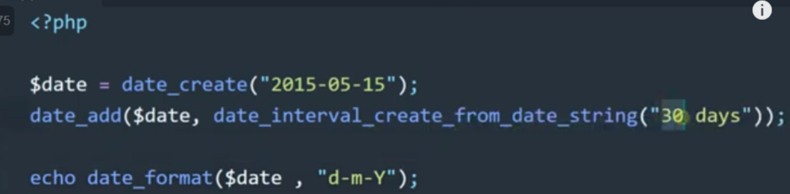

**Date modify :**

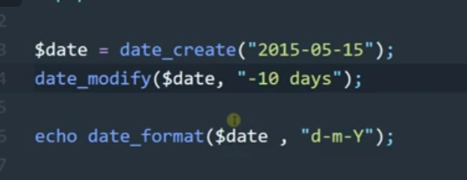

🡺 getdate() : function give current date and time in form of assosiative array .

ii) note we can get previous date and time by timestamp by using mktime and passing it as first parameter.

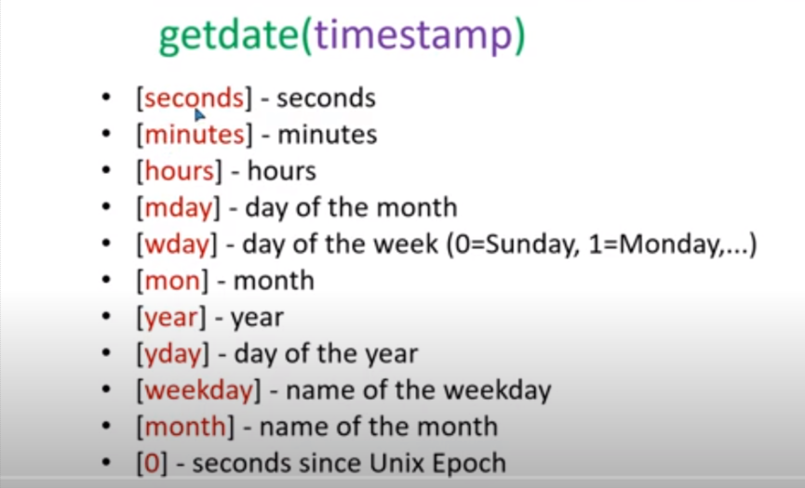

ii)gettimeofday():

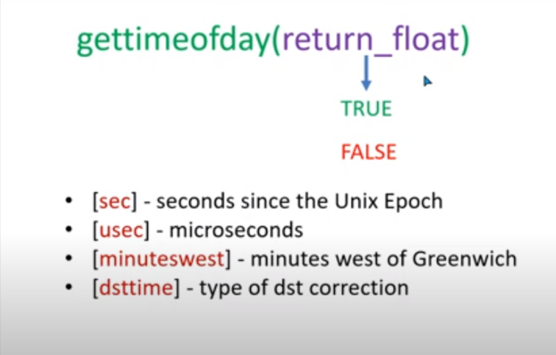

By default it has false value.

iii)localtime(timestamp,true/false):

to get current time :timestamp=time() and to get in form of assosiative array then true .

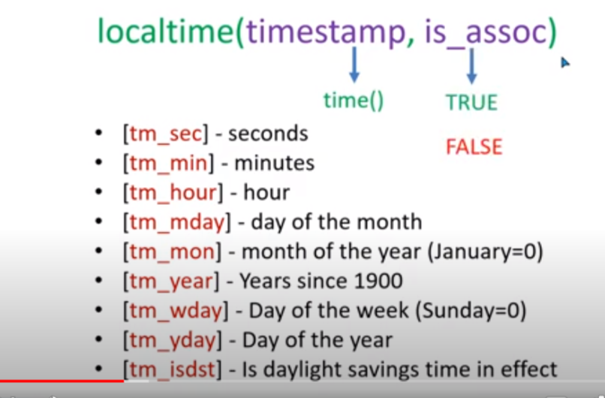

Note : we can also pass time as timestamp by using mktime .

🡺 include and require :

Syntax : <? php include ‘file_name’ ?>;

Difference between include and require :

i)if there is error in include file then it will going to give error and the remaning file load.

ii) if there is error in require file then it will give error and remaning file will not work .

incase of require :

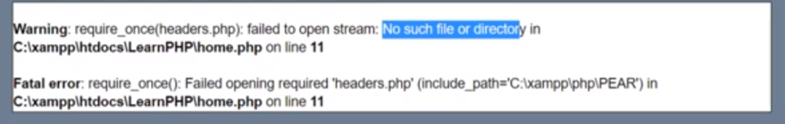

Incase of include :

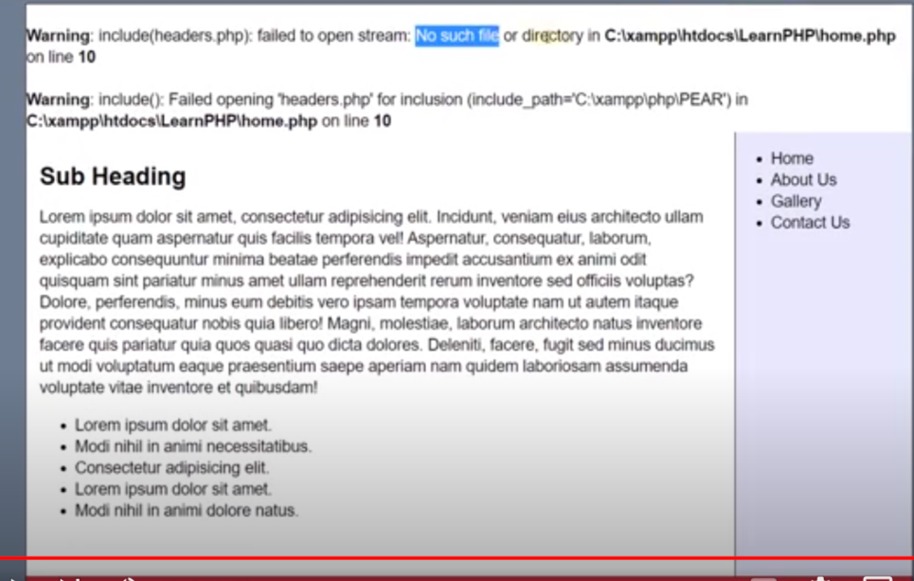

* Include_once and require once : it is used to remove duplicacy .

Super global variable :

If we want to transport data from one file to another file for that we use super global variable $post and $get;

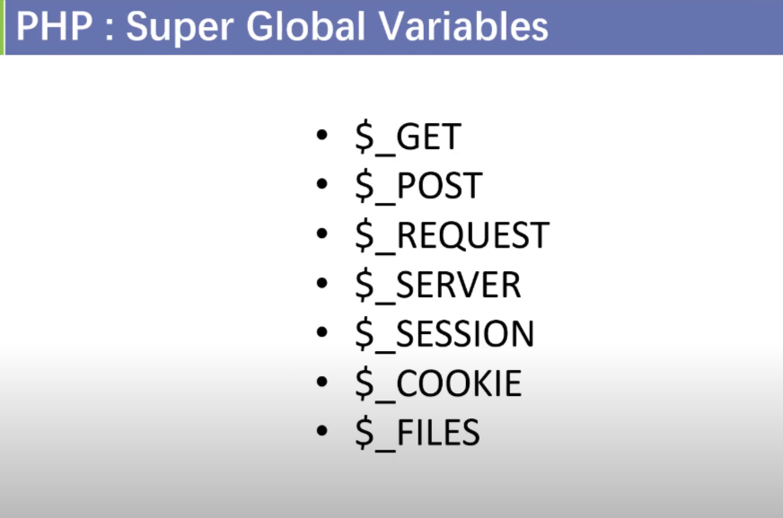

1.$_GET and $_POST global variable :

With the help of get and post global variable method we get data from the form .

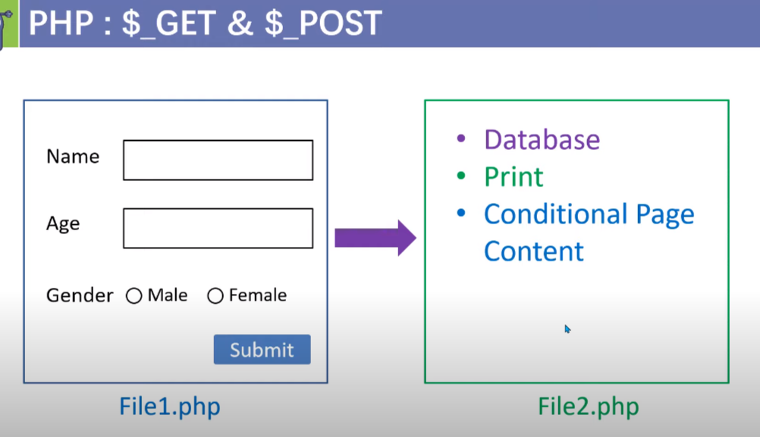

<!DOCTYPE html>

<html lang="en">

    <head>

        <meta charset="UTF-8" />

        <meta name="viewport" content="width=device-width, initial-scale=1.0" />

        <link rel="stylesheet" href="Index.css" />

        <title>Title</title>

    </head>

    <body>

        <div class="application">

            <form action="form.php" method="get">

                Name : <input type="text" name="myname"><br>

                id : <input type="text" name="myid"><br>

                D.O.B : <input type="date" name="mydob"><br>

                <input type="submit" value="submit" ><input type="reset" value="reset now">

            </form>

        </div>

    </body>

</html>

Note : it will going to give data in the form of array .

ii)name is must without name it may not going to work.

Difference between get and post :

Get : get give data of the fom in the url bar .

Eg : <http://localhost/FIRSTPHP/form.php?myname=ajaj+alam&myid=2020UMT1399&mydob=2022-07-12&submit=submit>

Post : donot give and data in the url .

Eg : <http://localhost/FIRSTPHP/form.php>

🡺 $_REQUEST : work with the both get and post .

ii) it give data in the form of associative array .

$_SERVER : with the help of server we will going to get the following information :

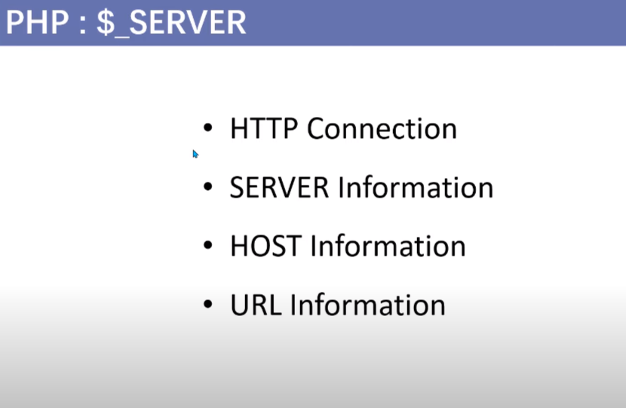

With the help of server we can get information about the form in the same page eg :

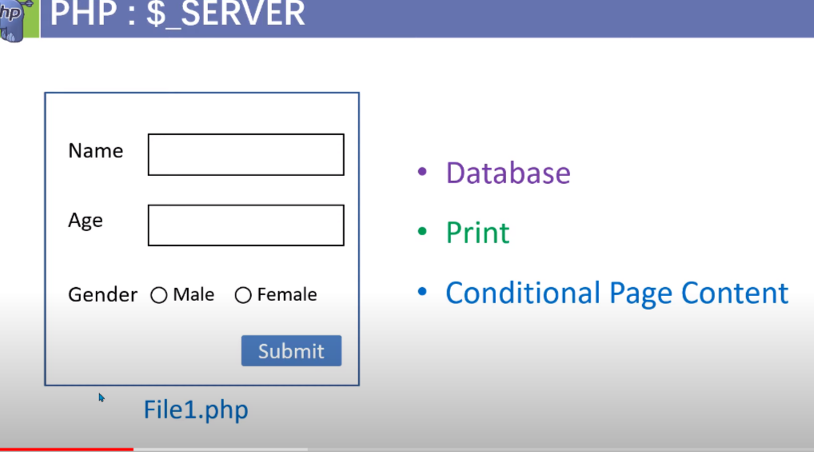

To get all the information about host,server,url ,http

<!DOCTYPE html>

<html lang="en">

    <head>

        <meta charset="UTF-8" />

        <meta name="viewport" content="width=device-width, initial-scale=1.0" />

        <link rel="stylesheet" href="Index.css" />

        <title>Title</title>

    </head>

    <body>

        <div class="application">

            <form action="form.php" method="post">

                Name : <input type="text" name="myname"><br>

                id : <input type="text" name="myid"><br>

                D.O.B : <input type="date" name="mydob"><br>

                <input type="submit" value="submit" ><input type="reset" value="reset now">

            </form>

        </div>

    </body>

</html>

Form.php:

<?php

echo "<pre>";

print_r($_SERVER);

echo "</pre>";

?>

To get the information about form in the same page :

<!DOCTYPE html>

<html lang="en">

    <head>

        <meta charset="UTF-8" />

        <meta name="viewport" content="width=device-width, initial-scale=1.0" />

        <link rel="stylesheet" href="Index.css" />

        <title>Title</title>

    </head>

    <body>

        <div class="application">

            <form action="<?php echo $_SERVER['PHP_SELF'] ?>" method="post">

                Name : <input type="text" name="myname"><br>

                id : <input type="text" name="myid"><br>

                D.O.B : <input type="date" name="mydob"><br>

                <input type="submit" name="save" ><input type="reset" value="reset now">

            </form>

            <?php

            if(isset($_POST['save'])){

                echo "<pre>";

                echo print_r($_POST);

                echo"</pre>";

            }

            ?>

        </div>

    </body>

</html>

* Cookies :set the a temporary information on the system of the visitor .

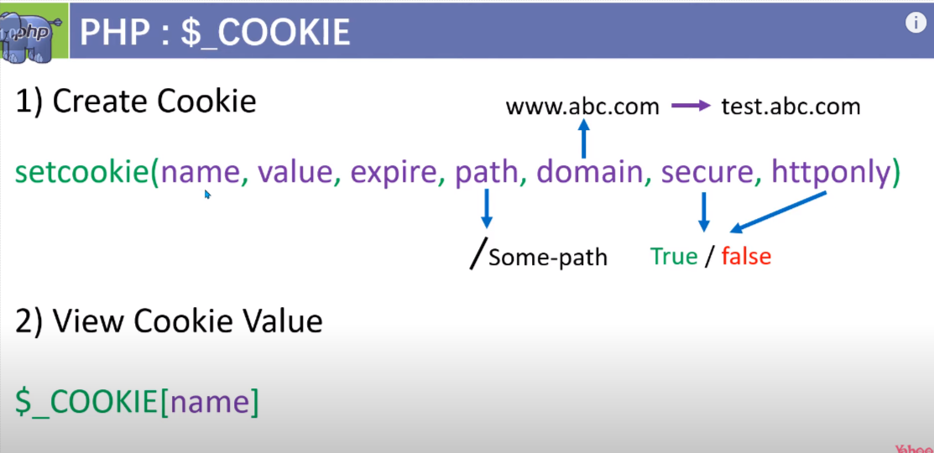

In setcookie :

Expire : we set time here and time should be in second by using time function :time()+n

Path : we path we want to open : ‘/’ to open in every page

Domain or subdomain :which domain or sub domain we want to open it .

Secure : if true :it will going to open in https(secure server port) server port .

If false : it will going to open for both http and https server port .

Httponly: if true : we get cookie by server side (by php ,python or node)

If false : we can get cookie by both client side(javascript ) or sever side (php)

Note : always set cookie at the top of .php main file .

<?php

$cookie_name="user";

$cookie_value="Ajaj";

setcookie($cookie_name,$cookie_value,time()+(60*60*24),'/');

?>

<!DOCTYPE html>

<html lang="en">

    <head>

        <meta charset="UTF-8" />

        <meta name="viewport" content="width=device-width, initial-scale=1.0" />

        <link rel="stylesheet" href="Index.css" />

        <title>Title</title>

    </head>

    <body>

        <?php

         if(isset(($_COOKIE['user']))){

            echo $_COOKIE['user'];

         }

        ?>

    </body>

</html>

Note :

I )we can get cookie into the other file also .

By : <?php

    echo $_COOKIE['user'];

    ?>

ii) if we want to delete the cookie :we set time expiry in neagtive

setcookie('user','',time()-(60*60*24),'/');

$_SECSSION : in session we save the temporary information on the serve .

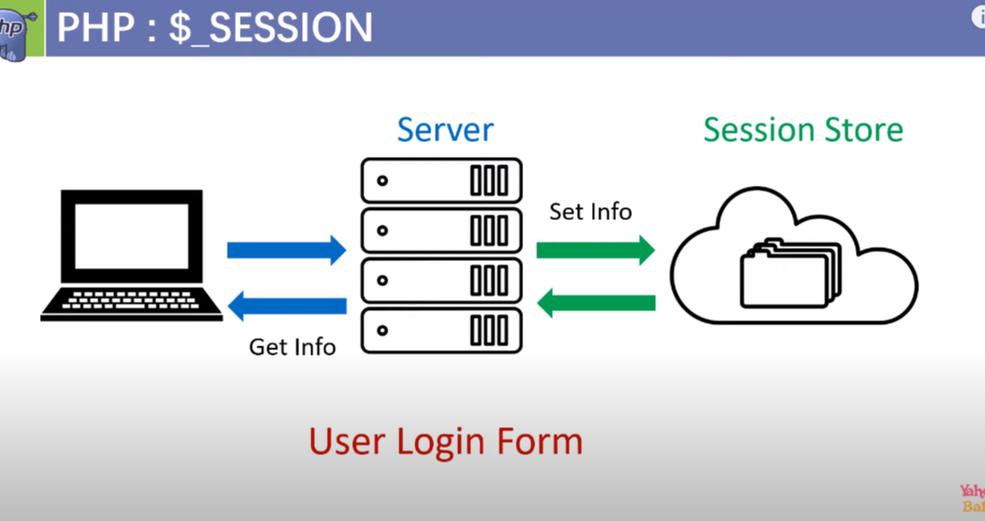

Step to create sessoion :

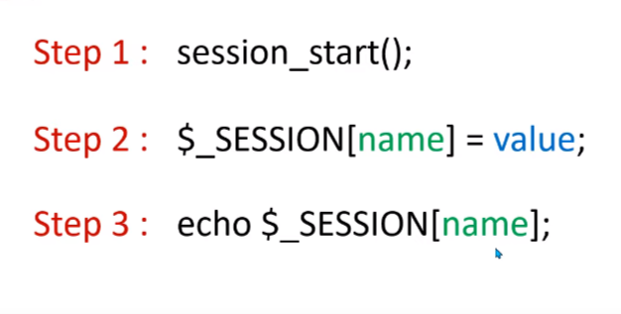

Note : sessoion store data in form of assosiative array .

To delete session:

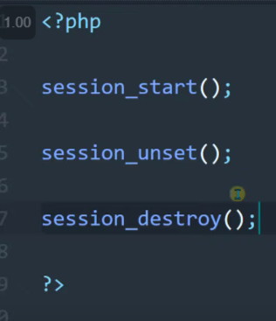

Note : when ever we need to create session or to use session or to delete session we need to start with the: session_start();

ii)we can get the session on the other page also.

Eg :

<?php

session_start();

echo "<pre>";

print_r($_SESSION);

echo "</pre>";

?>

To delete session :

<?php

session_start();

session_unset();

session_destroy();

?>

$_file: if we sent file from the client side to sotre that file we use $_FILES[name]

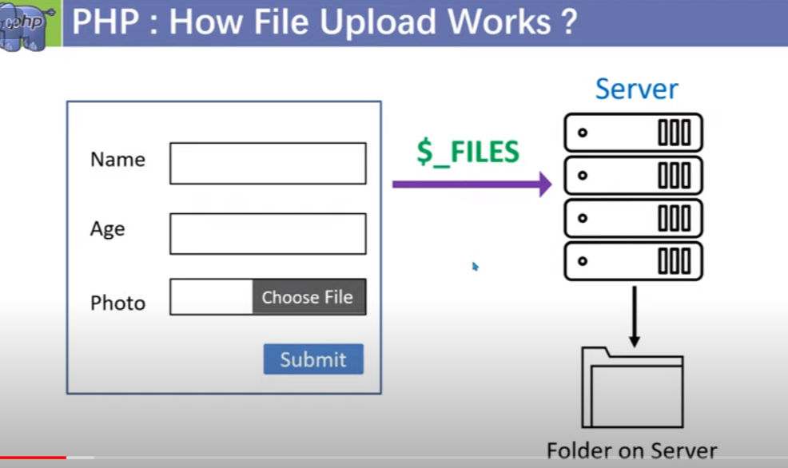

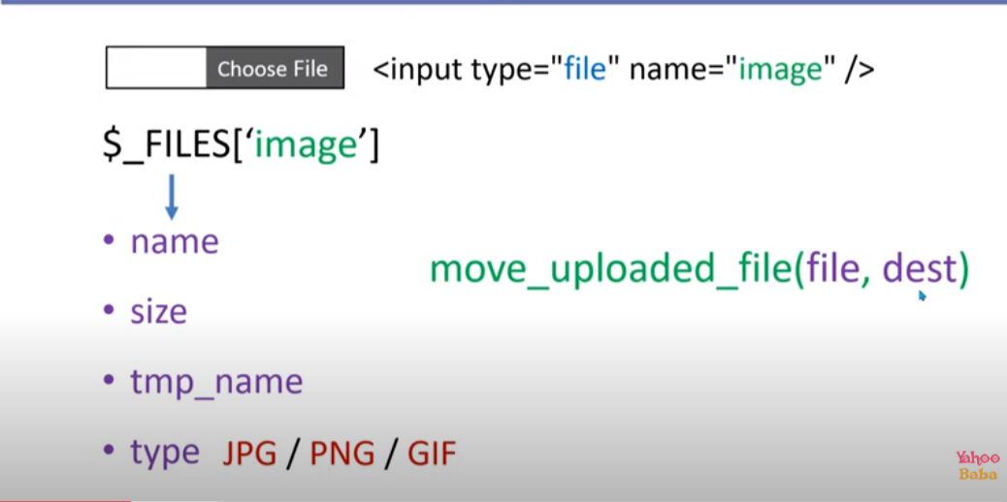

Create upload file :

<html>

    <body>

        <form action="" method="post" enctype="multipart/form-data">

            <input type="file" name="myimage"><br><br>

            <input type="submit" name="store">

        </form>

    </body>

</html>

<?php

if(isset($_FILES['myimage'])){

    echo "<pre>";

    print_r($_FILES['myimage']);

    echo "</pre>";

}

?>

Note : remember to use in form : enctype="multipart/form-data"

To upload a file :

<html>

    <body>

        <form action="" method="post" enctype="multipart/form-data">

            <input type="file" name="myimage"><br><br>

            <input type="submit" name="store">

        </form>

    </body>

</html>

<?php

if(isset($_FILES['myimage'])){

    move_uploaded_file($_FILES['myimage']['tmp_name'],'imgfile/'.$_FILES['myimage']['name']);

}

?>

Note : in move_uploaded_file() : file name will be temprory file name that can be get from the $_FILES[‘myimage’][‘temp_name’];

Die() and exist() function :

After we call die() or eixst() the code after that will not going to run .

It is used to check error :

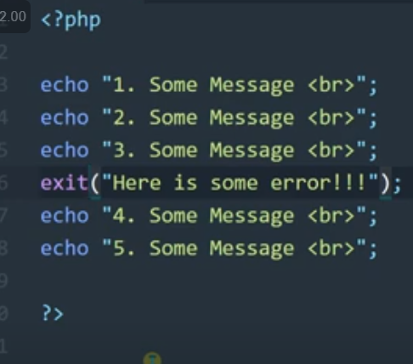

🡺 creating a database and creating a table and entring data from xampp server :

Setp 1 : click on rounded box :

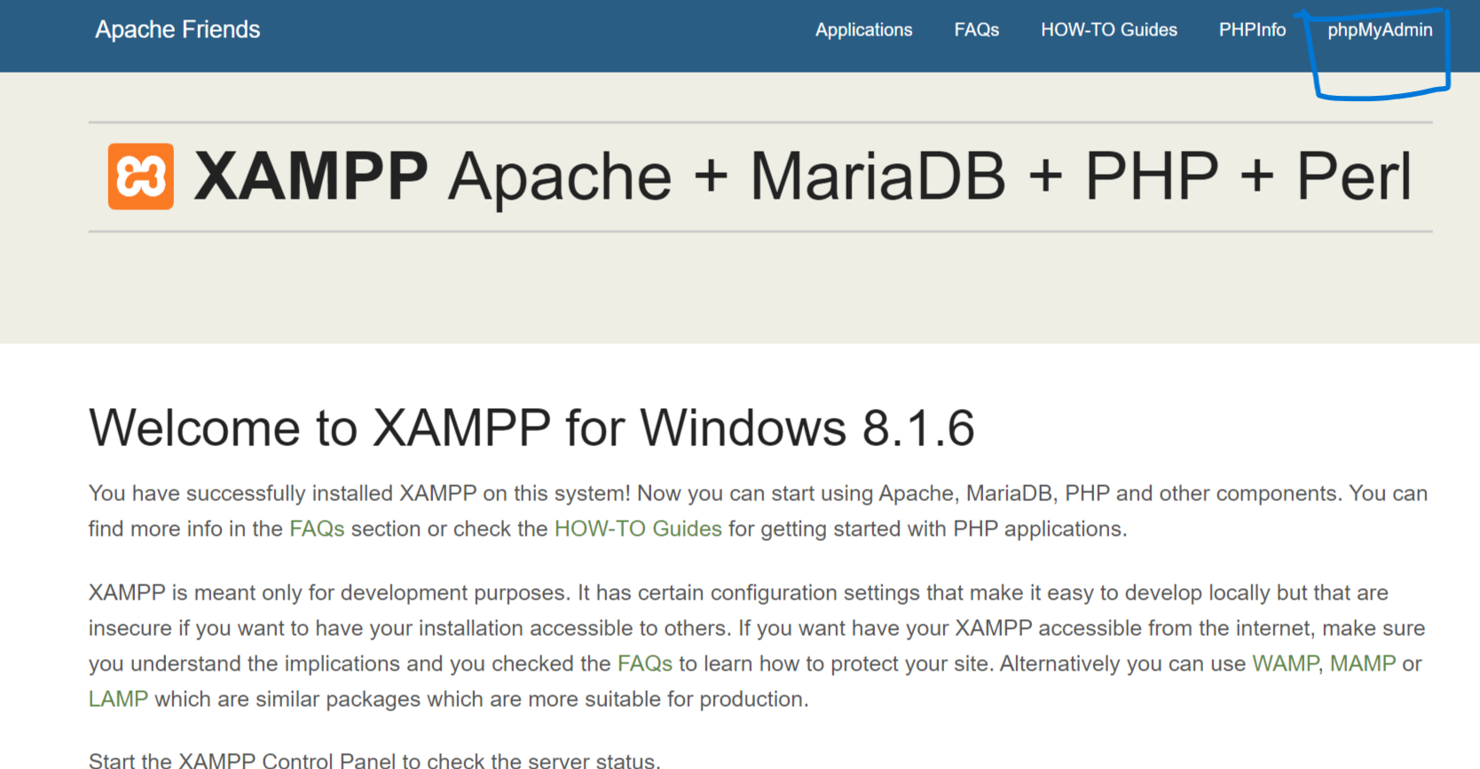

Step 2 : click on database :



Step 3 :write the name of your database on create database and click on create :

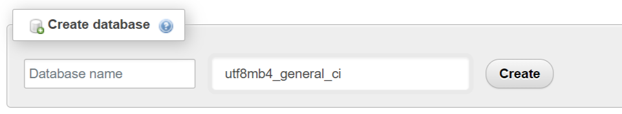

Step 4:write your table name and click on create :

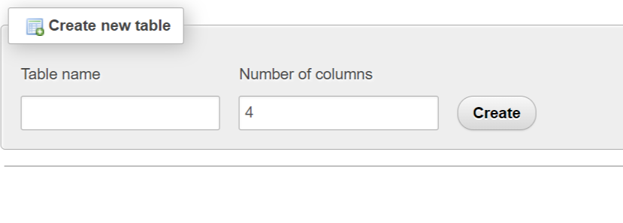

Step 5 :

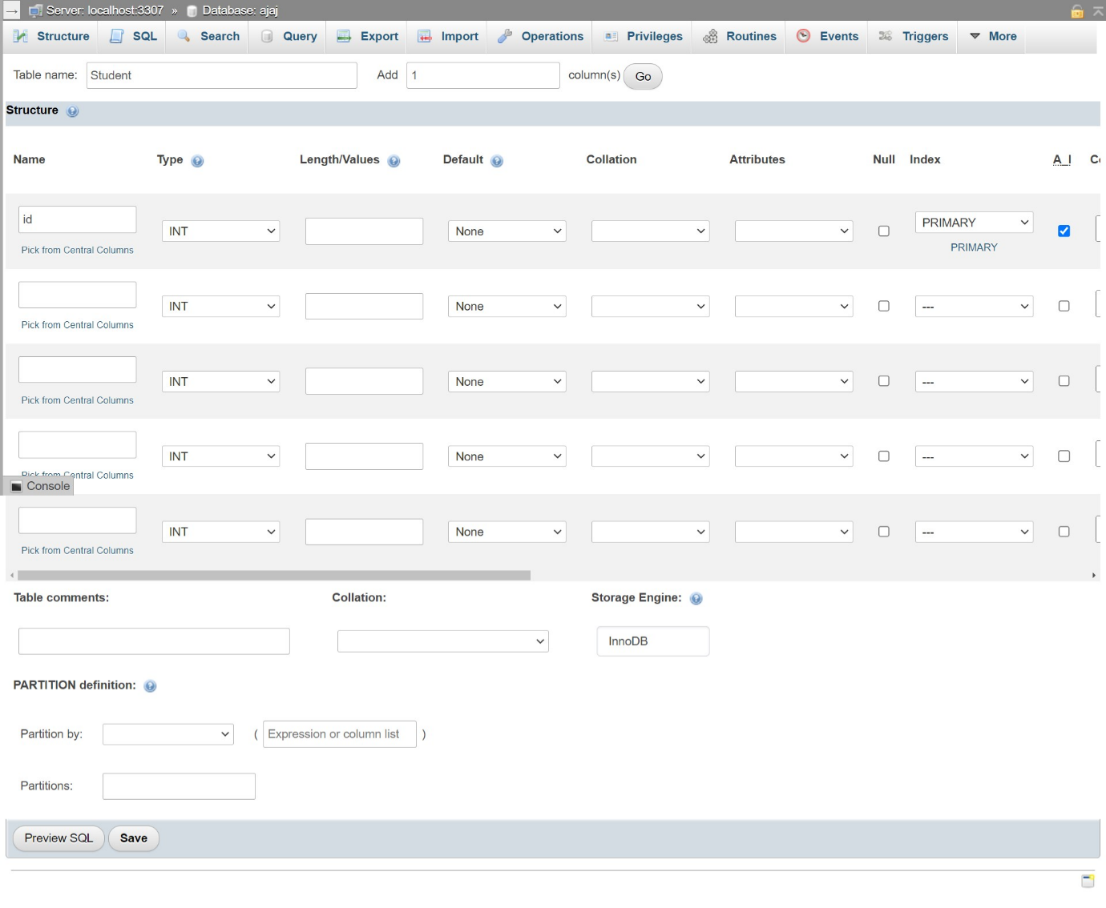

Step 6 :

Click on insert data and insert your data;

PHP CRUD OPERATION :

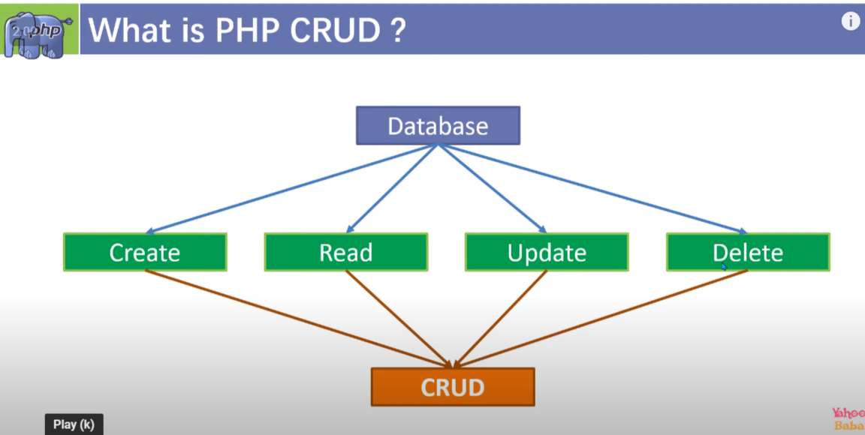

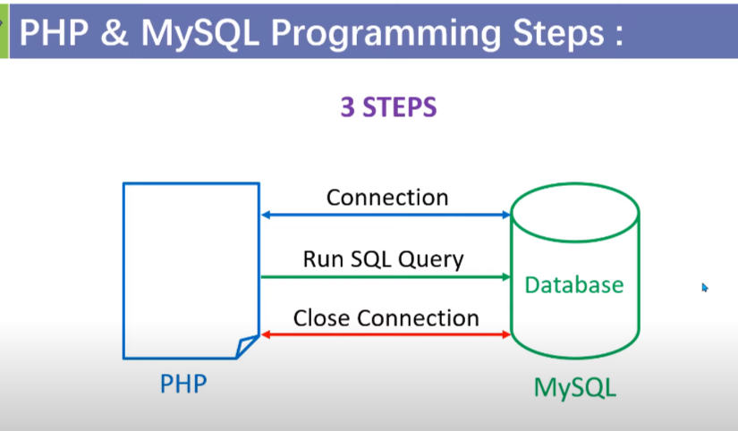

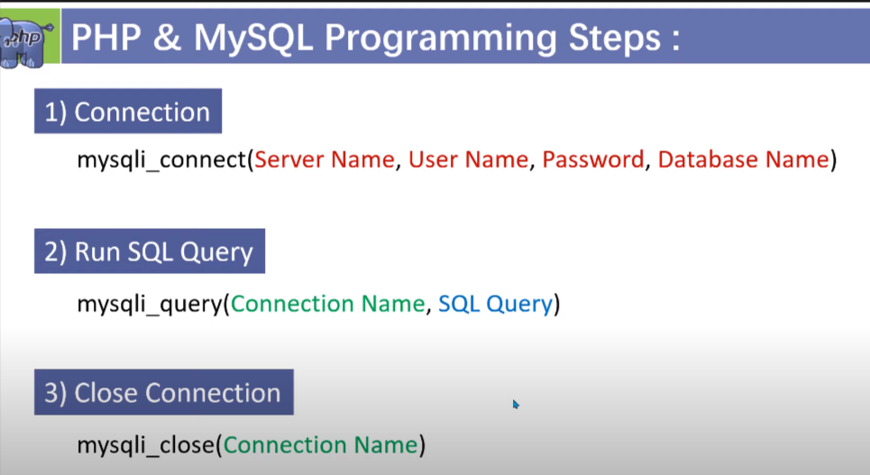

1. read data :

<?php

    $db_connect=mysqli_connect("localhost","root","Ajaj13994010#","crud") or die("db not connected");

    $result=mysqli_query($db_connect,"SELECT * FROM Student") or die("Query not excuted");

?>

<html>

    <body>

        <?php

        if(mysqli_num_rows($result)>0){

        ?>

        <table border="2px" cellpadding="10px" cellspacing="0">

            <thead>

                <tr>

                    <th>ID</th>

                    <th>NAME</th>

                    <th>ADRESS</th>

                    <th>CLASS</th>

                    <th>PHONE</th>

                    <th>ACTION</th>

                </tr>

            </thead>

            <tbody>

                <?php

                while($row=mysqli_fetch_assoc($result)){

                ?>

                <tr>

                    <td><?php echo $row['id'] ?></td>

                    <td><?php echo $row['Name'] ?></td>

                    <td><?php echo $row['Adress'] ?></td>

                    <td><?php echo $row['Class'] ?></td>

                    <td><?php echo $row['Phone'] ?></td>

                    <td>

                        <a href="#"><button>EDIT</button></a>

                        <a href="#"><button>DELETE</button></a>

                    </td>

                </tr>

            </tbody>

            <?php } ?>

        </table>

        <?php } ?>

    </body>

</html>